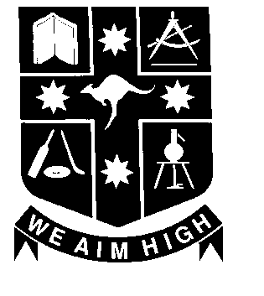

Kotara High School – Year 10 Science 2008
Dear Parents

All students in Year 10 study science for 5 periods per two week cycle. Science classes are arranged with 10SC-K, 10SC-T and 10SC-R as graded classes and 10SC-H, 10SC-G, 10SC-S and 10SC-L as ungraded classes.

Your child’s class is ______ Your child’s teacher/teachers is/are

The Science Department will provide both a half yearly and yearly report which reflects our school based assessment of your child’s performance in key areas.

Students will undertake units of study for approximately 5 weeks in the following areas:
- Ins and Outs of Atoms | - Changing Partners
- Spaced Out | - On the Move
- On the Crest of a Wave  - DNA | - Evolution Revolution  - Spare Parts
School based assessment is progressive and each topic will include tasks designed to gauge the level of student performance in some of the following areas.
- Knowledge and Understanding of science concepts
- Practical and Investigative skills in science
- Application of information and problem solving ability
- Communication and Social Interaction Skills
Individual tasks in each topic will be given as part of the teaching and learning program. All classes will undertake tasks to assess common outcomes for that component. This assessment will occur in normal class time and students will be given explicit criteria which provide guidelines for achievement. Student performance in these components will be reflected in school reports and show the degree to which specific outcomes relating to the Syllabus have been achieved.

Students will be awarded grades related to their performance in each task. The following levels of achievement in tasks reflect high expectations for students and link to levels of achievement of specific outcomes on school reports

Grade Limited Basic Sound High Outstanding
E 0-39% D 40-59% C 60-74% B 75-84% A 85% & above

Year 10 will undertake an ongoing program to prepare them for their school certificate exam. This will involve homework exercises, an ongoing summary booklet, skills development in graphing, tabulation and interpretation as well as research on scientific developments and technology. A major independent student research assignment will form the basis of the students’ Reflective Learning Project.

A Junior Science Progress Register (yellow sheet) has been issued for your child to place in their Science Notebook. It details application and performance in individual components of each topic. Parents are invited to regularly consult and sign this to provide additional feedback on their child’s progress.

Homework is given regularly by all teachers and is to be submitted each week in a plastic display folder. All students are encouraged to use their school diaries. Students will need two bound exercise books for Science, which must be covered with plastic due to risk of chemical spills. All students have been issued with a safety agreement. Please read through this with your child.

I hope your child has a successful and enjoyable year in Science. Please feel free to contact me or the class teacher at anytime concerning your child’s education and check on our website for what’s on in Science, copies of homework tasks and assessments. http://www.kotara-h.nsw.edu.au/

Yours sincerely

A Southward (Head Teacher Science) Parent’s Signature: __________________________________

