Kotara High School

Science
Trial School Certificate Examination
2009
General Instructions
Reading time - 10 minutes Total Marks (100)
Working time - 2.0 hours
- Board-approved calculators may be used
- Write using blue or black pen
- Draw diagrams using pencil

Your will be issued with
- A question booklet for Section 1 Part A and B
- An Answer Booklet containing Section 2 and an answer sheet for all questions from section 1 and 2
- A stimulus booklet containing information to assist in answering questions from sections 1 and 2

This paper has two sections:
Section 1 Part A Multiple Choice Use stimulus booklet Total marks (50)
Attempt questions 1 – 50 in answer booklet placing a cross for the correct answer

Part B Questions 51-60 Use stimulus booklet Total Marks (10)
Attempt questions 51- 60 in spaces on answer booklet

Section 2 Extended Response Questions Use stimulus booklet Total Marks (40)

Attempt Questions 51-67 in answer booklet in the spaces provided

This paper MUST NOT be removed from the examination room

1. Two colourless liquids are mixed together; the resulting clear solution is red.
Which of the following is a possible explanation?
(A) A new chemical compound was formed.
(B) A red precipitate formed.
(C) The colourless liquids were dilute.
(D) A third solution must have been added.

2. The diagram indicates the evolutionary path taken by our Sun, its present position, and the path it is predicted to take over the remainder of its "life".

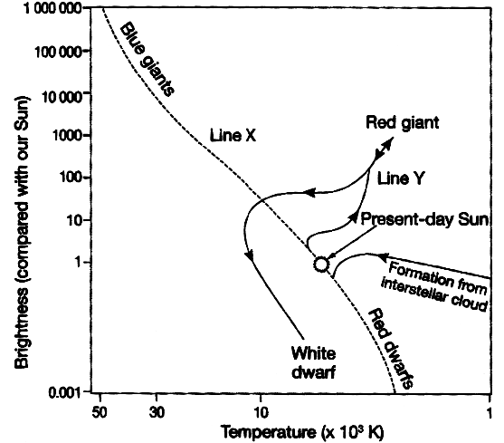
According to this information, which statement is correct?
(A) The Sun is about half way through its "life".
(B) In the next stage of its evolution the Sun may be a red giant.
(C) The Sun commenced its "life" as a white dwarf.
(D) Red dwarfs are formed from interstellar cloud.

3. Which diagram shows a possible path of a ray of light through a glass slab?

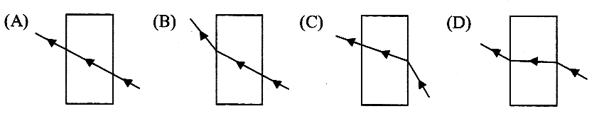

4. In which organ of the female body does an embryo usually develop?
(A) Ovary
(B) Fallopian tubes
(C) Oviduct
(D) Uterus
5. The diagram shows part of the scale on a meter.

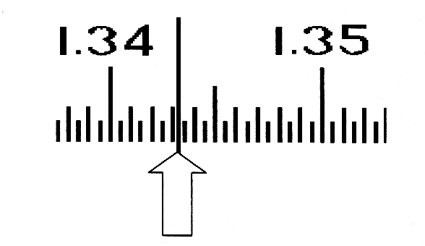

What is the reading on the scale where the arrow is pointing?
(A) 1.3343 (B) 1.3430
(C) 1.3435 (D) 1.3463

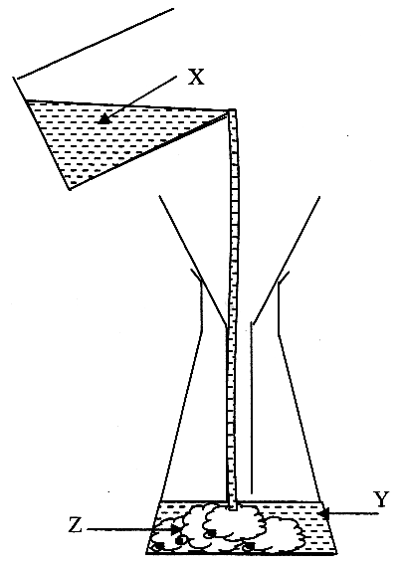
Use the following information to answer Questions 6 - 8.

6. The diagram shows a precipitation reaction. Which statement about this reaction is correct?
(A) X and Y are both insoluble chemicals.
(B) X and Y react to form Z.
(C) Y and Z are both products of the reaction.
(D) X contains a chemical indicator.

7. Which statement about chemical Z is correct?
(A) It will be composed of atoms rather than molecules.
(B) It will contain equal numbers of atoms from X and Y.
(C) It will be composed of atoms from both X and Y.
(D) It will be more soluble in X than in Y.

8. Which piece of apparatus is shown in the diagram?
(A) Beaker (B) Filter paper
(C) Pipette (D) Stirring rod

9. Which of the following involves coordination between the endocrine and nervous systems of the human body?
(A) Knee jerk reaction (B) Cell division by mitosis
(C) Bodily response to stress (D) Kicking a football

10 Which of the following methods of producing electricity is the LEAST environmentally friendly?
(A) Burning coal to produce steam to turn generator turbines
(B) Using tidal flow in rivers and oceans to turn generator turbines
(C) Using wind to turn generator turbines
(D) Using solar cells to convert light energy into electricity directly

11. In New South Wales, the main source of electricity is from coal-fired power stations. What is the main reason for this?
(A) Oil fuelled power stations produce too much pollution.
(B) Alternate sources of energy are not as economical.
(C) Uranium is only found in the Northern Territory.
(D) New South Wales does not get sufficient wind or sun light to use these as energy sources.

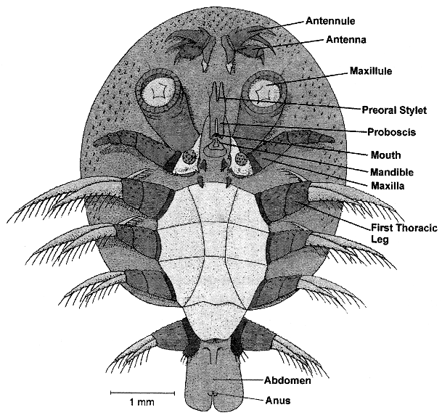
12. The following diagram of a parasitic tick is drawn to scale.
What is the approximate maximum width of the body of the tick?

(A) 1.0 mm
(B) 4.1 mm
(C) 6.2 mm
(D) 9.3 mm

Use the following information to answer Questions 13 and 14.
The diagram represents a series of vertical rock layers found in a cliff face. The geometric shapes represent different types of fossils found in the layer of rock.

13. Which statement regarding this sequence of rock layers and the fossils is correct?
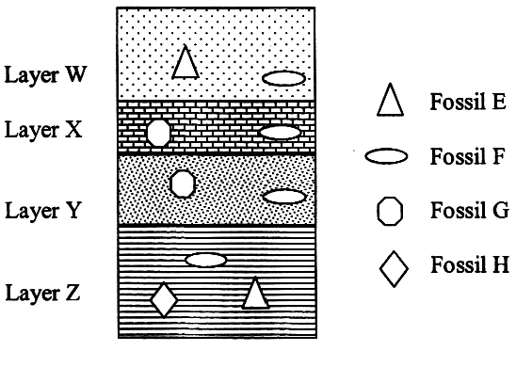
(A) Rock layer Y is younger than rock layer W.
(B) Fossil F is older than fossil E.
(C) Rock layer X is older than fossil F.
(D) Fossil H is older than rock layer Y.

14. What is the main use for geological records like this?
(A) To find evidence for the presence of economic mineral deposits
(B) To determine the age of rocks and to study the evolution of life on earth
(C) To prove Darwin's theory of evolution correct
(D) To provide evidence for the theory of plate tectonics
15. The table shows the levels of pollution in the atmosphere at two different locations (X and Y).

Pollutant | Concentration of pollutant at location X (PPM) | Concentration of pollutant at location Y (PPM)
Coarse dust particles (>0.1 mm)  Fine dust particles (<0.1 mm)  Oxides of nitrogen  Carbon monoxide  Sulfur dioxide | 225  157  2  4  2 | 4  8  0  1  0

Which of the following is a possible reason for the difference in these results?
(A) Both X and Y are city locations.
(B) Both X and Y are isolated country locations
(C) X is in the city, Y is in an isolated country location.
(D) X is an isolated country location, Y is in the city.

16. The diagram shows the behaviour of white light as it passes through a glass prism. Which statement explains the phenomenon shown in the diagram?

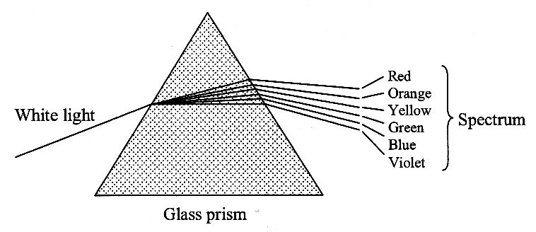

(A) Prisms disperse white light.
(B) White light is made up of all the colours of the rainbow.
(C) The amount of refraction of light depends on its wavelength.
(D) White light cannot pass through glass.

17. Assume that an astronaut travels from the Earth into outer space.
Which of the following is correct about her weight and mass as she travels?
 | Mass | Weight
(A) | constant | constant
(B) | constant | decreases
(C) | decreases | constant
(D) | decreases | decreases

18. A spaceship is travelling in deep space where the gravitational force is zero. How will the spaceship move if the rockets are switched off?
(A) Toward the nearest planet (B) Decelerate
(C) Accelerate (D) At constant speed
19. Who is credited with describing the structure of DNA?
(A) Watson and Crick (B) Hertzsprung and Russell
(C) Darwin (D) Einstein

20. The diagram shows a common classification of star types. In general, for stars plotted on the diagonal Main Sequence, the closer a particular star is to the top left hand corner of this diagram, the larger, hotter and brighter it is.

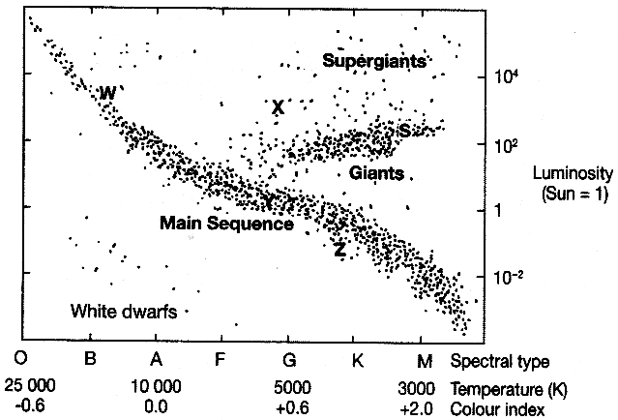
From this information, which of the following is correct?
(A) Star X is cooler, larger and brighter than star Z.
(B) Star X is hotter, smaller and brighter than star W.
(C) Star W is hotter, larger and brighter than star Z.
(D) Star Z is cooler, larger and duller than star X.

21. What is the advantage of DNA mutation?
(A) The cloning of organisms to maintain population numbers
(B) The possible appearance of a new characteristic useful for survival
(C) The development of a healthy organism that may survive to reproduce
(D) The exact replication of chromosomes to ensure no error is passed on

22. The plate tectonic model involves the concept of zones of weakness within the Earth. Where are these zones of weakness located?
(A) At all boundaries between crustal plates
(B) Where one crustal plate rises on top of another crustal plate
(C) In regions where mountain ranges are forming
(D) In deep oceanic trenches
23. Cars convert the chemical energy in fuels into other energy forms. The car in the diagram produces 25 joules of kinetic energy and 75 joules of heat energy from every 100 joules of chemical energy.

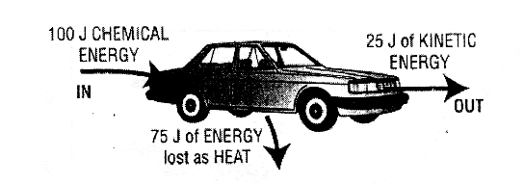
The efficiency of a machine is calculated using the formula:
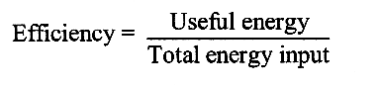
What is the efficiency of the car shown?
(A) 0.25 (B) 0.33
(C) 0.75 (D) 100

Use the following information to answer Questions 24 and 25.
When bats fly, they emit high frequency sounds. The echoes produced give bats information about their surroundings. The diagram shows the oscilloscope traces of the original sound by a bat and the echo.

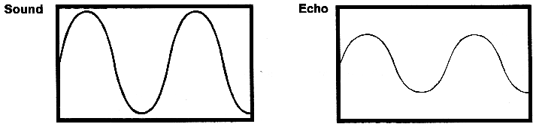

24. Which property of waves is being used by bats?
(A) Reflection (B) Refraction
(C) Dispersion (D) Absorption

25. Comparing the traces, which wave characteristic has changed?
(A) Frequency (B) Speed
(C) Wavelength (D) Amplitude

26. Which list contains only abiotic features of an environment?
(A) Temperature, flora, fauna
(B) Wind speed, temperature, humidity
(C) Living organisms, food sources, temperature
(D) Oxygen concentration, degree of acidity, green plants

27. The diagram shows a section of the Earth.
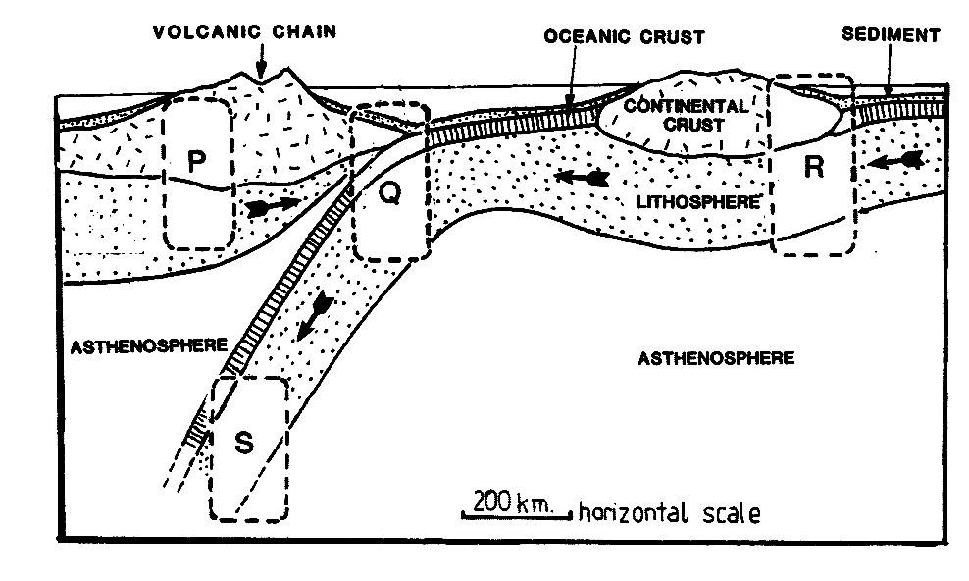
Where on the diagram would earthquakes be most likely to occur?
(A) In the region marked P
(B) In the region marked Q
(C) In the region marked R
(D) In the region marked S

28. Which list only contains forms of electromagnetic radiation?
(A) X-rays, microwaves, earthquake waves
(B) Radio waves, gamma rays, infra-red heat
(C) Alpha, beta and gamma radiation
(D) Light, ultraviolet light, sound

29. Which of the following types of electromagnetic radiation is LEAST useful for communicating information across long distances?
(A) Microwaves
(B) Radio waves
(C) TV waves
(D) Visible light
Use the following information to answer Questions 30 and 31.
The drawing shows the relationship between the oxidant and the reductant in a chemical reaction involving oxidation and reduction, called a redox reaction.

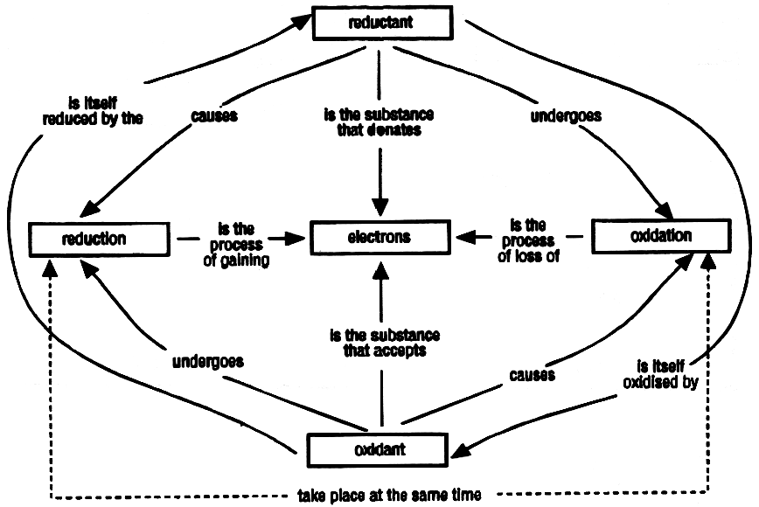

30. Which term describes this kind of drawing?
(A) Graph (B) Flow chart
(C) Spreadsheet (D) Diagram

31. A substance that accepts electrons during a chemical reaction describes which of the following?
(A) Oxidant (B) Oxidation
(C) Reductant (D) Reduction

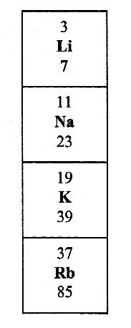
Use the following information to answer Questions 32 to 34.
The diagram to the right represents a section of the Periodic Table. 32

32. Potassium is element number 19 on the Periodic Table. Its atomic symbol is K and it is often represented as ¹⁹ K₃₉.
What does this additional information tell us about potassium atoms?
(A) A potassium nucleus has 39 neutrons.
(B) A potassium nucleus has 20 protons.
(C) A potassium nucleus has 20 neutrons.
(D) A potassium nucleus has 39 protons.

33. Which of the four elements shown would be the least chemically active?
(A) Li (B) Na
(C) K (D) Rb
34. When these four elements react with chlorine, the chemical compounds formed (lithium chloride, sodium chloride, potassium chloride and rubidium chloride) are all classified as salts.
Why are they classified in the same group?
(A) All these compounds have the same type of name.
(B) All four compounds have the same physical properties.
(C) All four compounds have similar chemical properties.
(D) All four compounds have constant physical properties.

35. According to the theory of plate tectonics, plates move over the mantle. What causes this movement to happen?
(A) Different density rocks in the crust
(B) The presence of molten rock in deep ocean trenches
(C) Convection currents in the mantle
(D) Fault lines which exist between the crustal plates

36. At different stages in the history of aeroplanes, various materials have been used in their construction. The table lists some of the relevant properties of a number of these materials.

Material | Density  g/cm³ | Strength  GPa | Stiffness  GPa | Relative  cost
Aluminium alloy | 2.8 | 0.6 | 90 | low
Steel | 7.8 | 1.0 | 210 | low
Wood | 0.6 | 0.1 | 20 | low
Glass reinforced plastic | 1.9 | 1.5 | 21 | medium
Kevlar plastic | 1.5 | 3.0 | 190 | high

Why is glass reinforced plastic a suitable material for the wings of a small aeroplane?
(A) It is relatively stiff and fairly strong.
(B) It is relatively light, strong and not too expensive for small wings.
(C) The wings must be transparent and flexible.
(D) It is not as dense as aluminium and cheaper.

37. Observe the following image.

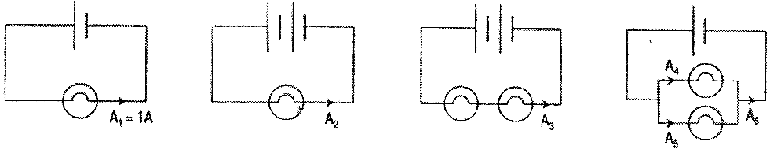
The light globes and batteries used in each of the four circuits are identical.
Which statement describes how the currents compare?
(A) Current A1 = current A2
(B) Current A₂ = current A₃
(C) Current A1 = current A4 = current A5
(D) Current A3 = current A6

38. Earth-based telescopes, such as the radio telescope at Parkes in NSW, are usually very large.
Which of the following is the reason for the large size of such telescopes?
(A) The wavelengths of the electromagnetic radiation reaching Earth from distant objects are very long.
(B) To collect electromagnetic radiation from near stars
(C) To collect a lot of electromagnetic radiation in a short time
(D) To collect as much as possible of the very low intensity electromagnetic radiation reaching Earth from distant objects

39 Enzymes are important because they alter the rate of chemical reaction in organism. The effect of an enzyme depends on the reaction conditions, such as temperature and the acidity (pH) of the solution.
Below are graphs showing some information about a reaction that is sped up using an enzyme.
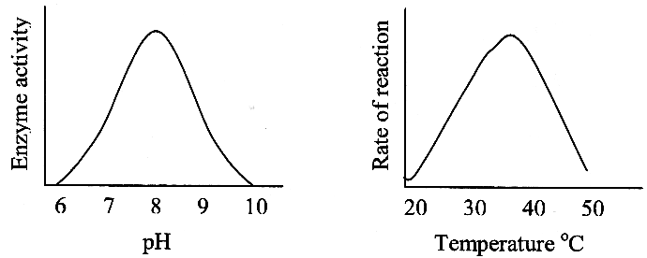
From the graphs, what are the best conditions for maximum rate of reaction?
 | pH | Temperature
(A) | 10 | 50°
(B) | 6 | 20°
(C) | 6 | 50°
(D) | 8 | 37°

Use the graph below to answer Questions 40 and 41.

The graph shows the relationship between thickness of mud deposited in a region and the thickness of shale rock formed when that mud dries out and compresses.
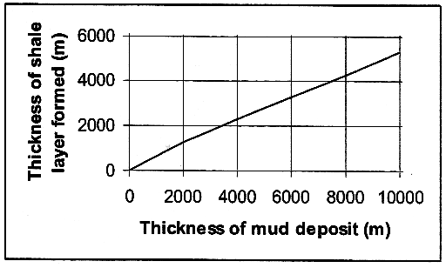
40. According to this information, what is the thickness of the shale layer formed by a 4,500 m thick mud deposit?
(A) About 2 200 m
(B) About 3 000 m
(C) About 3 200 m
(D) About 8 500 m

41 The diagram shows a vertical sequence of rocks in a cliff face. The diagram is drawn to a scale where 1 cm = 1 500 m.

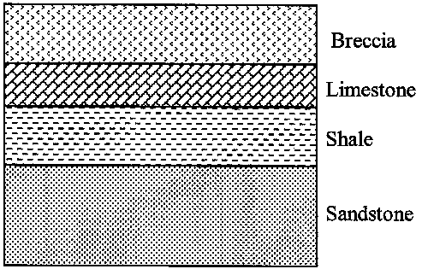

Using the graph, approximately how thick was the mud deposit that resulted in the formation of the shale in this cliff face?
(A) 1 000 m
(B) 1 650 m
(C) 2 000 m
(D) 2 500 m

Use the following information to answer Questions 42 and 43.
DNA codes for the production of chemicals needed for life. Protein synthesis takes place in the cytoplasm surrounding the cell nucleus. A messenger molecule takes the genetic code from the nucleus to the cytoplasm.
The messenger code is read in groups of three bases called triplets. Each triplet codes for a particular amino acid. The protein is built up, amino acid by amino acid. The order of the different amino acids depends on the order of triplets on the DNA. When the complete message has been read, the protein is complete and can carry out its function.

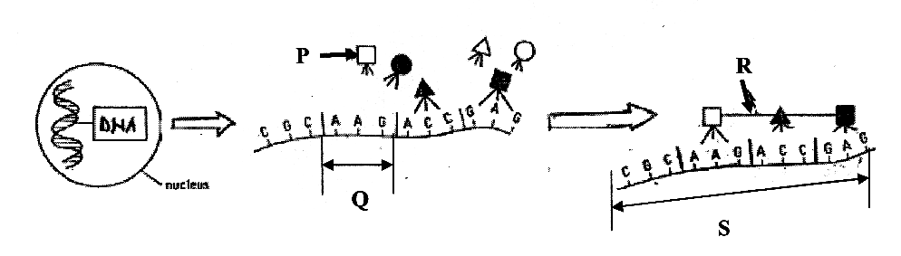

42 A messenger molecule has 30 bases.
What is the composition of the protein produced?
(A) Ten DNA triplets
(B) Ten amino acids
(C) Ten bases
(D) Thirty amino acids
43. Which alternative correctly labels the parts of the diagram?
 | P | Q | R | S
(A) | messenger  molecule | triplets | amino acid | protein
(B) | triplets | messenger  molecule | protein | amino acid
(C) | amino acid | triplets | protein | messenger  molecule
(D) | amino acid | messenger  molecule | protein | triplets

44. ‘Safe-T- Cam’ is a point-to-point speed camera which takes an image showing the number plate of the passing vehicle.
A second ‘Safe-T-Cam’ many kilometres away recognises the same vehicle from the number plate and takes a second image.
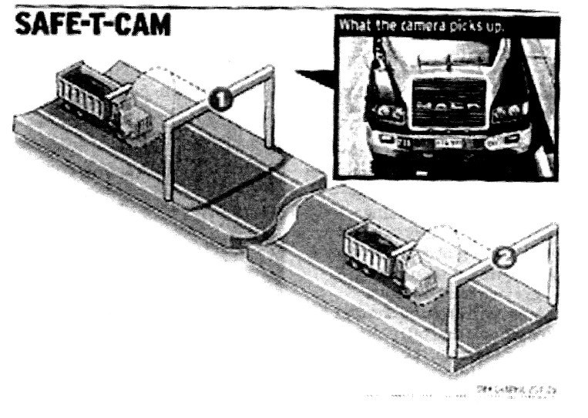
What information is needed by the `Safe-T-Cam' system to determine if a motorist is speeding?
(A) Only the time taken between being photographed by the two cameras
(B) The speed recorded by the second `Safe-T-Cam'
(C) The average speed recorded at each `Safe-T-Cam'
(D) The distance between the two cameras taking the images, as well as the time taken between being photographed at the two cameras

Questions 45 to 50 refer to the Stimulus Booklet.

Questions 45 and 46 refer to Source A.

45. What does the reliability of a set of experimental results refer to?
(A) Whether or not all the variables in the experiment have been controlled
(B) Whether or not the results of the experiment are consistent when the experiment is repeated
(C) Whether or not the experiment measures the variables accurately
(D) Whether or not the experiment has been designed properly
46. According to the information in the passage, when is it appropriate to make a conclusion for an experiment?
(A) After all tests and observations have been made
(B) When a hypothesis that answers the question has been found
(C) When a result supports the hypothesis
(D) When repeated experiments show the same results

Questions 47 and 48 refer to Source B.

47. What would be an appropriate hypothesis for this experiment?
(A) Radioactivity can be stopped by lead sheets.
(B) The stronger the radiation, the more counts per minute we will get on the Geiger Counter.
(C) The further the lead sheeting is from the radioactive source, the less the count will be.
(D) Thicker sheets of lead will stop more radiation than thinner sheets of lead.

48. Which conclusion is most appropriate for this experiment?
(A) Thick lead sheets stop more radioactivity than thin lead sheets.
(B) Thick lead sheets are more efficient in stopping radioactivity than thin lead sheets.
(C) Radioactivity penetrates thick lead sheets better than thin lead sheets.
(D) The radiation absorbed by a lead sheet is directly proportional to its thickness.

Questions 49 and 50 refer to Source C.

49. What is the symbol for the unknown element in the graph?
(A) Na 24 (B) Zn 72
(C) As 71 (D) 1124

50. From the data on radioactive isotopes used in medicine, which of the following is the most likely half-life of molybdenum-99?
(A) 66 minutes (B) 6 hours
(C) 66 hours (D) 6 months

Section I – continued

Part B
Total marks (10)
Attempt Questions 51- 60
Allow about 20 minutes for this part

Answer the questions in the spaces provided.

Question 51 Marks
What name do we give to a group of millions of stars held together by gravity? 1

Question 52 1
What is the term used to describe a group of organs in our body that have related functions?

Question 53 1
When hydrochloric acid is reacted with zinc metal, one product is a salt. What is the other
product?
Marks
Question 54 1
What term describes diseases that are easily passed from one person to another?

Question 55 1
Which activity of cells allows growth and repair in multicellular organisms?

Question 56 1
What is the name of the particle orbiting the nucleus of an atom?

Question 57 1
What word describes particles that are made up of two or more atoms joined together?

Question 58 1
What is the name of the scientist who developed the idea of natural selection to explain the variety of organisms on Earth?

Question 59 1
As well as an earthquake, what other natural event can occur when crustal plates move over each
other.
Question 60 1
What is the unit of force?

End of Section 1

