Kotara High School

Science
Trial School Certificate Examination
2008
General Instructions
Reading time - 10 minutes Total Marks (100)
Working time - 2.0 hours
- Board-approved calculators may be used
- Write using blue or black pen
- Draw diagrams using pencil

Your will be issued with
- A question booklet for Section 1 Part A and B
- An Answer Booklet containing Section 2 and an answer sheet for all questions from section 1 and 2
- A stimulus booklet containing information to assist in answering questions from sections 1 and 2

This paper has two sections:
Section 1 Part A Multiple Choice Use stimulus booklet Total marks (50)
Attempt questions 1 – 50 in answer booklet placing a cross for the correct answer

Part B Questions 51-60 Use stimulus booklet Total Marks (10)
Attempt questions 51- 60 in spaces on answer booklet

Section 2 Extended Response Questions Use stimulus booklet Total Marks (40)

Attempt Questions 51-67 in answer booklet in the spaces provided

This paper MUST NOT be removed from the examination room
1. Students react different metals with dilute hydrochloric acid. A teacher provides the following list of safety rules.
Rule 1: Wear a laboratory coat when using corrosive or flammable liquids.
Rule 2: Never point a test tube at any person or yourself.
Rule 3: Use a heat mat to protect the bench from hot objects.
Rule 4: Do not smell any gaseous products unless instructed by a teacher.
Rule 6: Wear heat proof gloves when handling hot glassware.
Rule 7: Do not pour chemicals down the sink.
Rule 8: Never eat or drink in the laboratory.
Rule 9: Do not play with the power points.
Which of the rules would NOT be relevant for this experiment?
(A) Rule 9 only
(B) Rules 3 and 6 only
(C) Rules 3, 6 and 9
(D) Rules 6, 8 and 9

2. A parachutist is descending at constant speed toward the ground.
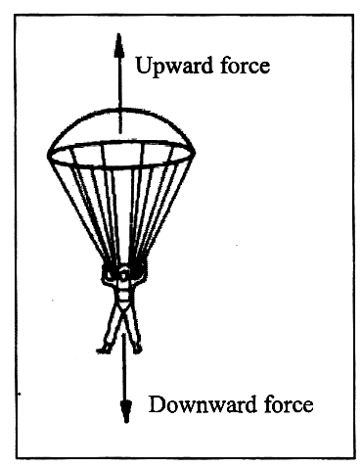
Which statement describes the relationship between the two forces acting on the parachutist?

(A) The forces are equal as the acceleration is zero.
(B) The downward force is greater than the upward force as the parachutist is moving downwards.
(C) The downward force of gravity is cancelled out by the greater upward force.
(D) There is neither upward nor downward forces acting on the parachutist as he is moving at constant speed.

3. Velocity (v), frequency (f) and wavelength (λ) are connected by the wave equation:
v = f x λ
What is the wavelength of a wave if its speed is 340 ms⁻¹ and its frequency is 200 Hz?

(A) 1.7 m
(B) 0.6 m
(C) 550 m
(D) 68 000 m

4. The scaled diagrams below show different fossil shells found in sandstone rock around Sydney. Estimate the approximate width of the largest shell. (you may use a ruler)
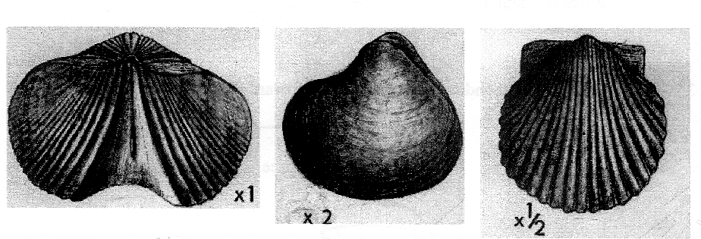
(A) 20 mm
(B) 54 mm
(C) 80 mm
(D) 40 mm

5. Which of the following describes where electrons, protons and neutrons are found in atoms?

 | Electrons | Protons | Neutrons
(A) | Outside the nucleus | Inside the nucleus | Inside the nucleus
(B) | Outside the nucleus | Inside the nucleus | Outside the nucleus
(C) | Inside the nucleus | Inside the nucleus | Outside the nucleus
(D) | Inside the nucleus | Outside the nucleus | Inside the nucleus

6. The diagrams below show the structure of a number of different chemicals.
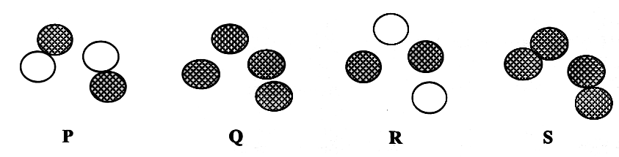

Which diagram represents molecules of an element?

(A) P
(B) Q
(C) R
(D) S

7. Which scientific theory describes the origin of the universe?

(A) creationism
(B) plate tectonics
(C) the Big Bang theory
(D) the theory of Evolution
Use the information in the diagram to answer Questions 8 - 10.
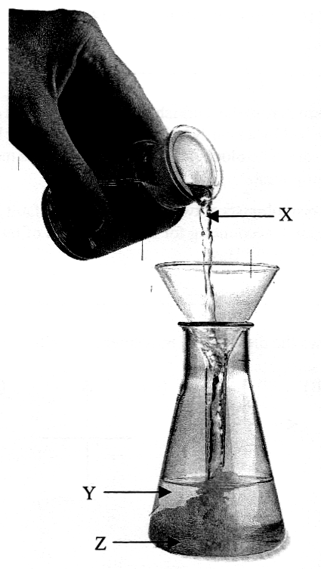

8. Which of the following best describes the type of reaction occurring in the diagram?

(A) combustion reaction
(B) decomposition reaction
(C) neutralisation reaction
(D) precipitation reaction

9. Which of the following correctly identifies X, Y and Z?

 | X | Y | Z
(A) | Reagent | Reagent | Product
(B) | Reagent | Product | Reagent
(C) | Product | Reagent | Reagent
(D) | Product | Reagent | Product

10. Which statement about the new compound formed during this reaction is correct?

(A) It is formed as a result of the reacting chemicals forming new atoms.
(B) It is formed as atoms from compounds break down to form atoms
(C) It is formed as a result of some atoms in the reacting chemicals being rearranged and combined.
(D) It is formed when the nuclei in the reacting chemicals are changed into different nuclei.
Use the information below to answer Questions 11-14.

A fissure stretching 100 km across the Turkish landscape provides evidence for the extraordinary force unleashed by an earthquake, in which two vast blocks of rock snapped apart under pressure. The block north of the fault line is moving east and the block to the south is moving west.
Measurements taken by seismologists at two points along the fault line show the ground moved 2.5 m in a split second, accounting for the destruction of buildings over such a wide area and a tidal wave in Ismit Bay.

11. Which alternative shows the direction of movement along the fault line?
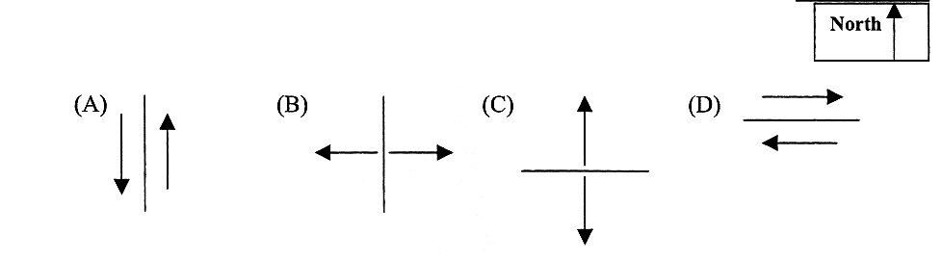

12. Which of the following is a common impact of an earthquake?

(A) high winds
(B) radiation sickness
(C) a series of after shocks
(D) thick layers of ash in the upper atmosphere

13. Which theory accounts for movement of large sections of the Earth's crust?

(A) plate tectonics
(B) volcanism
(C) relativity
(D) seismology

14. Which of the following do scientists believe is the energy source for the movements of the Earth's crusts?

(A) nuclear reactions in the core
(B) convection currents in the crust
(C) convection currents in the mantle
(D) the gravitational pull of the moon
Use the information below to answer Questions 15 -18.
The table below outlines the classification of stars used by astronomers.
Star Type | Colour | Temperature
O | Blue | 30,000 K
B | Blue | 20,000 K
A | White | 10,000 K
F | Yellow | 7,000 K
G | Bright yellow | 6,000 K
K | Orange | 4,000 K
M | Red | 3,000 K

The above classification system resulted in a graphing of stars in the Milky Way. The graph shown below is similar to the one drawn by Henry Russell. The stars between the diagonal lines are known as Main Sequence stars. The stars well above the Main Sequence to the right are giant stars while those well below the Main Sequence to the left are dwarfs.
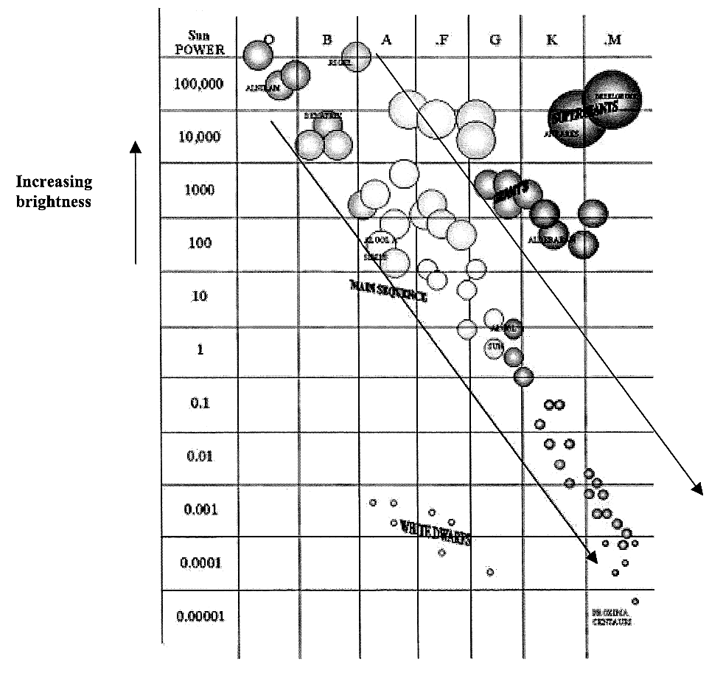
15. What is the colour of a Type A star?

(A) red
(B) orange
(C) yellow
(D) white
16. A Main Sequence star has a temperature of 30 000 K.
What approximate brightness (in `Sun Power') is predicted by Russell's graph?
(A) 1
(B) 100,000
(C) 1,000
(D) 0.001

17. Based on the information in the table, which scale could be used on the horizontal axis of the graph?
(A) distance from the Earth
(B) age of a star
(C) temperature
(D) rate of nuclear reactions

18. Which of the following conclusions is justified by the information provided above?
(A) As temperature decreases, star brightness increases.
(B) As well as Main Sequence stars, there are red dwarf stars and white giant stars.
(C) The brightest stars in the Universe are white giants.
(D) As temperature decreases, star brightness decreases.

19. Observe the diagram below. P, Q and R show the same rubber strip with no load, 1 kg and 2 kg masses hanging from the rubber strip. The appearance of the atoms in the strip in each situation is shown beside each strip. S shows a rubber strip which is twice the width of P, Q and R, and the same length.

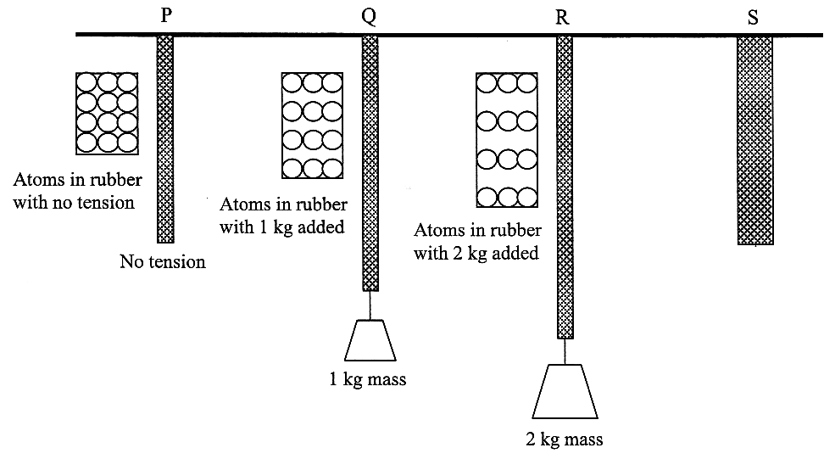

Which choice below would most likely represent how the atoms are spaced if a 2 kg mass were added to strip S?
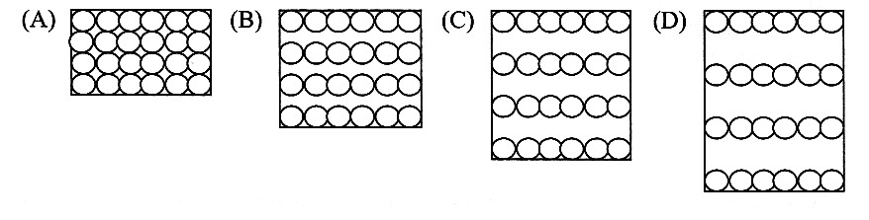
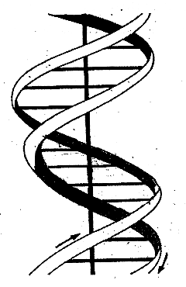
20. The diagram below represents which structure found within organisms?

(A) a part of a cell membrane
(B) a strand of hair
(C) a nerve fibre
(D) a part of a chromosome

Use the information to answer Questions 21- 24.
The diagram below represents how mosquitoes infect people with the malaria parasite and how it is passed on to other mosquitoes.

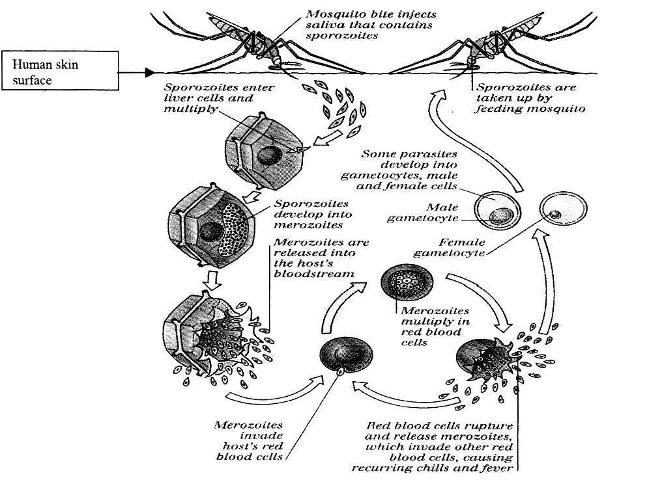

Researchers have recently produced a genetically modified (GM) mosquito which is resistant to infection by the malaria parasite, and therefore has a much longer survival rate. It is hoped that when these are released into malaria infected areas, the mosquito responsible for passing on the infection will die out and be replaced by the malaria resistant mosquito and so break the life cycle. It is hoped that offspring from the GM mosquito will also be resistant to the malaria parasite.

21. How many stages are there in the life cycle of the malaria parasite?

(A) 1
(B) 2
(C) 4
(D) 8
22. What causes the high fever and chills associated with malaria?

(A) sporozoites which reproduce in the liver cells
(B) merozoites which cause liver cells to burst and then move into the bloodstream
(C) sporozoites multiplying within red blood cells
(D) red blood cells rupturing to release many more merozoites into the bloodstream

23. Which statement best describes how genetically modified (GM) mosquitoes will assist in breaking the malaria parasite life cycle?

(A) The GM mosquitoes are better adapted to survive and will out-compete the non-modified mosquitoes.
(B) Non-GM mosquitoes will die as they become infected with the malaria parasite.
(C) GM mosquitoes will be less able to compete for food than the non-GM mosquitoes and will slowly die out.
(D) GM mosquitoes will prey on non-GM mosquitoes and the parasite.

24. Which alternative correctly matches the part of the human reproductive system with its function?

 | Organ | Function
(A) | Fallopian tube | Passage for menstrual flow
(B) | Uterus | Site of fertilisation of ovum
(C) | Prostate gland | Storage vessel for sperm
(D) | Cervix | Opening between uterus and vagina

25. The table below gives information about four chemical particles.
Which of these particles is an atom of an element?

 | Number of protons | Number of neutrons | Number of electrons
(A) | 6 | 6 | 5
(B) | 6 | 6 | 6
(C) | 6 | 7 | 7
(D) | 6 | 7 | 8

26. A scientist flying in a plane at a high altitude above the Earth used equipment to determine the mass and weight of a metal ball. Another scientist on the ground at sea level also determined the mass and weight of an identical ball.
Which of the following is correct of the measurements taken in the two locations?

 | Mass | Weight
(A) | Same | Greater in plane
(B) | Same | Less in plane
(C) | Greater in plane | Same
(D) | Less in plane | Same

27. Observe the diagram below that represents a ray of light travelling into a glass that has a coin on the bottom. The glass contains water. A person is looking at the coin.

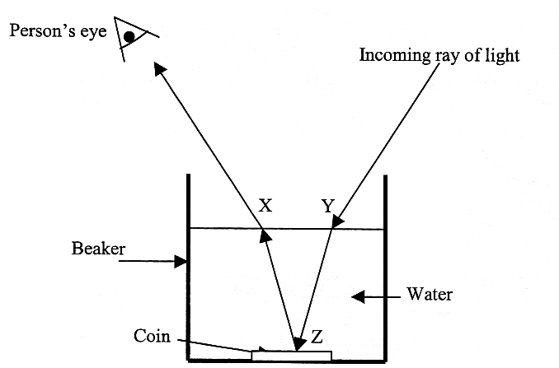

Which of the following is correct of what happens at X, Y and Z?

 | X | Y | Z
(A) | Refraction | Scattering | Refraction
(B) | Refraction | Reflection | Refraction
(C) | Refraction | Refraction | Reflection
(D) | Reflection | Scattering | Reflection

Use the following information to answer Questions 28 - 32.
The solubility of salts in water is affected by the temperature of the water. Solubility is measured in grams per 100 grams (or millilitres) of water. The solubility of four salts at different temperatures is shown on the graph. When no more solid is able to dissolve, the solution is said to be saturated and the undissolved solid falls to the bottom of the container.
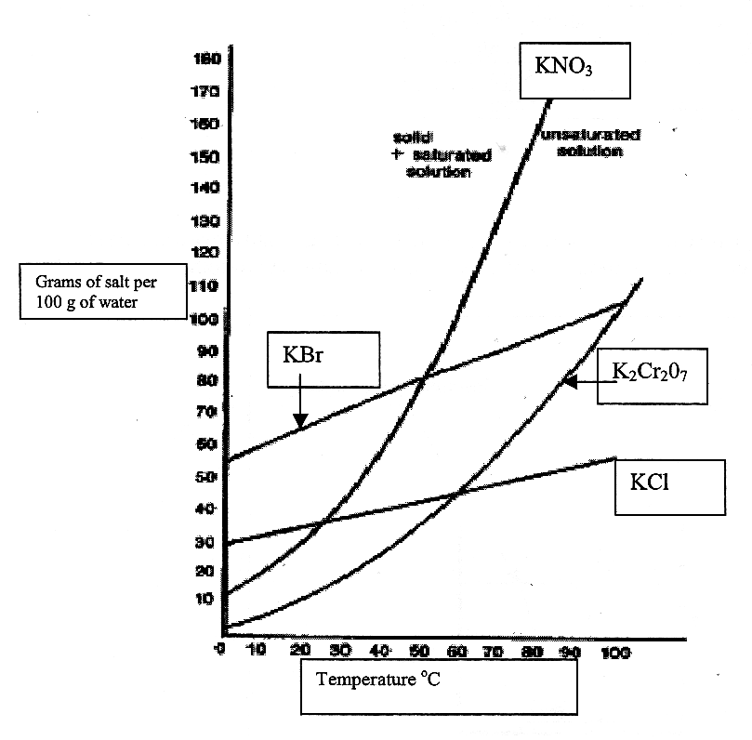

28. At which temperature do the salts KN03 and KCl have the same solubility?

(A) 25⁰C
(B) 35⁰C
(C) 45⁰C
(D) 55⁰C

29. What is the chemical name for the salt that has the chemical formula KCl?

(A) potassium chlorine
(B) sodium chlorite
(C) sodium chlorate
(D) potassium chloride
30. At a temperature of 40 °C, which salt is most soluble and which salt is least soluble?

(A) K₂Cr₂0₇ is the most soluble and KBr is the least soluble salt.
(B) KBr is the most soluble and K₂Cr₂0₇ is the least soluble salt.
(C) K₂Cr₂0₇ is the most soluble and KN0₃ is the least soluble salt.
(D) KN0₃ is the most soluble and KBr is the least soluble salt

31. Under which of the following conditions does 100 g of KN0₃ dissolve?

(A) at 80°C in 100g of water
(B) at 60°C in 100g of water
(C) at 40°C in 100g of water
(D) at 50°C in 100g of water

32. What conclusion about the solubility of salts can be made based on the graph?

(A) The solubility of the salts tested all increase at the same rate as temperature increases.
(B) At all temperatures, salts containing oxygen are more soluble than salts that do not contain oxygen.
(C) The solubility of all salts increases as temperature increases.
(D) The solubility of the salts tested increases as temperature increases.

33. The diagram below shows information about one of the elements on the Periodic Table.

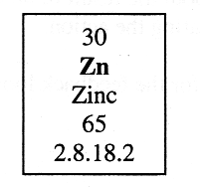

Which statement about the number of protons and electrons in this element is correct?

 | Number of protons | Number of electrons
(A) | 30 | 30
(B) | 30 | 35
(C) | 35 | 30
(D) | 35 | 35

Use the following information to answer Questions 34 - 37.
The diagram below shows an electrical circuit built by a student during an experiment. Assume that all electrical connections are good and that there are no breaks in the circuit. The switch is ON.

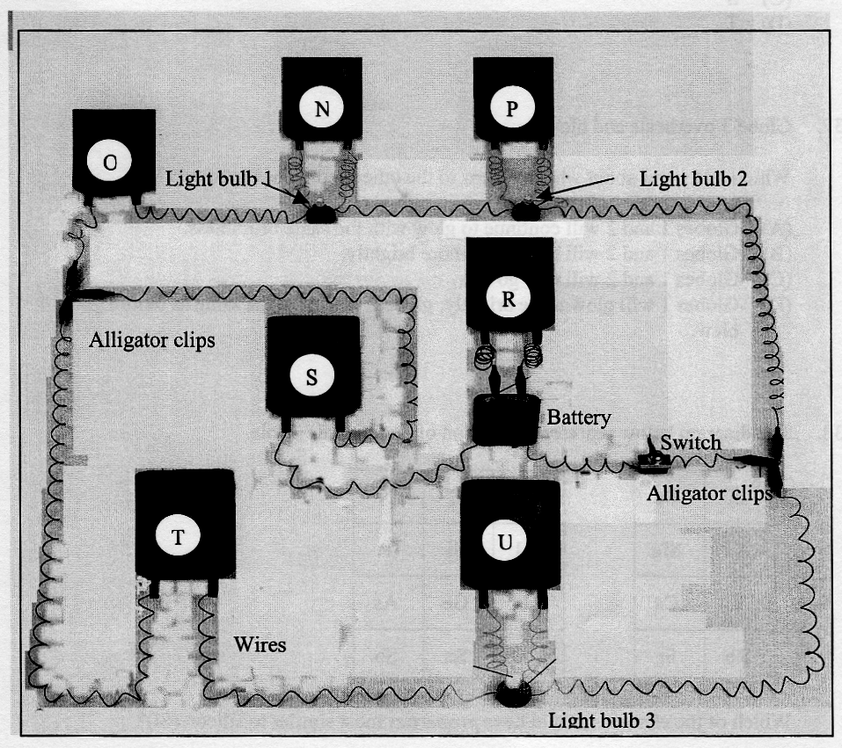

34. Which meters are voltmeters?
(A) R only
(B) Q, S and T only
(C) N, P and R only
(D) N, P, R and U only

35. Which statement about this circuit is correct?
(A) Light bulbs 1 and 3 are connected in parallel with each other and in series with globe 2.
(B) Light bulbs 1 and 2 are connected in series with each other and in parallel with globe 3.
(C) Light bulbs l, 2 and 3 are all connected in parallel with each other.
(D) Light bulbs 1, 2 and 3 are all connected in series with each other.

36. Which meter will indicate the largest current flow?
(A) Q
(B) R
(C) S
(D) T

37. Globe 3 overheats and blows.
Which statement about what happens to the other two globes is correct?
(A) Globes 1 and 2 will continue to glow with the same brightness.
(B) Globes 1 and 2 will both glow more brightly.
(C) Globes 1 and 2 will also go out.
(D) Globes 1 will glow more brightly; globe 2 will glow the same as before globe 3 blew.
38. The diagram below represents a section of the Periodic Table.

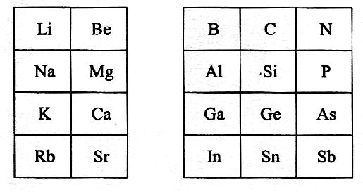
Which of the elements would have properties most similar to silicon (Si)?

(A) A1
(B) Ge
(C) N
(D) P

39. Which of the following is a series of changes that astronomers believe may occur during the life of a star?

(A) red giant  white dwarf  nebula
(B) nebulae adult star red giant
(C) black hole supernova adult star
(D) supernova red giant neutron star

Questions 40 - 44 refer to Source A.

40. What is the most appropriate aim for this experiment?

(A) to compare the strength of bacteria X and Y
(B) to compare the effect of different antibiotics on two types of bacteria
(C) to compare the sizes of the zones of sensitivity around two different bacteria
(D) to compare the sizes of the zones of sensitivity around four different antibiotics

41. Which of the following was inferred during the experiment?

(A) The stronger the antibiotic; the larger the zone of sensitivity.
(B) The weaker the antibiotic; the larger the zone of sensitivity.
(C) The stronger the bacteria; the larger the zone of sensitivity.
(D) The weaker the bacteria; the larger the zone of sensitivity.

42. Which statement about the effectiveness of the four antibiotics is correct?

(A) Antibiotic P would be best to use against either type of bacteria.
(B) Antibiotic Q is the strongest antibiotic.
(C) Antibiotic R is equally effective against either type of bacteria.
(D) Antibiotic S is more effective against bacteria X than against bacteria Y.

43. Which statement about two different types of bacteria is correct?

(A) Bacteria X is generally more affected by the antibiotics used than bacteria Y.
(B) Bacteria X is stronger than bacteria Y.
(C) Bacteria X is more resistant to the antibiotics used than bacteria Y.
(D) Bacteria X is a weaker type of bacteria than bacteria Y.
44. Which antibiotic would be best to use against an infection caused by both bacteria type X AND type Y?

(A) antibiotic P
(B) antibiotic Q
(C) antibiotic R
(D) antibiotic S

Questions 45 - 47 refer to Source B.

45. In what year was the atmospheric temperature on earth equal to 15°C?
(A) 1948
(B) 1950
(C) 1958
(D) 1965

46. The atmospheric temperature in the northern hemisphere has risen more than in the southern hemisphere over the last 25 years.
Which of the following could explain this?
(A) The population of the southern hemisphere is much larger than the population of the northern hemisphere.
(B) There is more pollution in the air in the northern hemisphere so the greenhouse effect is greater.
(C) The hole in the ozone layer is above the southern hemisphere and this allows more energy to escape into space.
(D) The sun's rays are more intense on the northern hemisphere than on the southern hemisphere.

47. What was the atmospheric temperature in 1925?
(A) 14.6°C
(B) 14.7°C
(C) 14.8°C
(D) 15.0°C

Questions 48 - 50 refer to Source C.

48. Which of the following is an example of corrosion?
(A) sodium hydroxide + hydrochloric acid  sodium chloride + water
(B) sodium carbonate + hydrochloric acid  sodium chloride + carbon dioxide + water
(C) magnesium + oxygen  magnesium oxide
(D) magnesium carbonate + heat  magnesium oxide + carbon dioxide

49. Given that the metals in the table are listed in decreasing order of chemical activity, which statement is correct?
(A) Iron will react with dilute hydrochloric acid more quickly that magnesium.
(B) Zinc will react with oxygen in the air more quickly than magnesium.
(C) Magnesium would react with dilute sulfuric acid more quickly than calcium.
(D) Copper would react with nitric acid more slowly than lead.

50. If the metals listed in the table react with concentrated nitric acid, then nitrogen dioxide is formed instead of nitrogen oxide.
What is the correct formula for nitrogen dioxide?
(A) N₂0
(B) N0₂
(C) N₂O₂
(D) 2N0
Section I - continued Part B
Total marks (10)
Attempt Questions 51- 60
Allow about 20 minutes for this part

Answer the questions in the spaces provided.

Question 51 (1 mark) Marks

Name the group of compounds that are able to neutralise acids. 1

Question 52 (1 mark)

The diagram represents a section of a 10 mL measuring cylinder. The shaded area represents water.
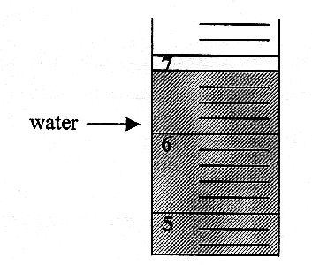

What is the reading on the measuring cylinder? 1

Question 53 (1 mark)

What is the formula for sulfuric acid? 1

Question 54 (1 mark)

Write a word equation for the reaction between dilute nitric acid and zinc. 1

Question 55 (1 mark)
The graph below shows the human menstrual cycle.

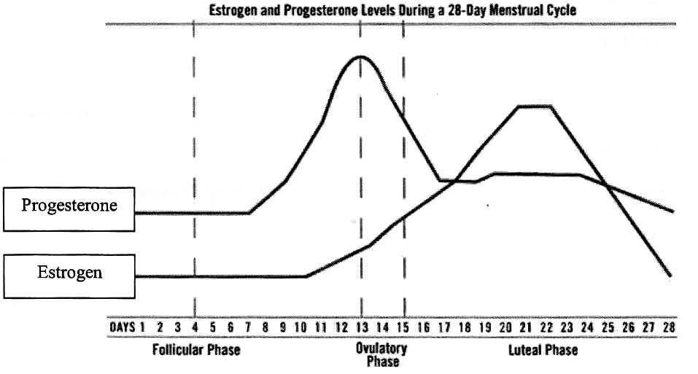

For how many days of the cycle is the concentration of oestrogen greater than the concentration of progesterone? 1

Question 56 (1 mark)

What is the term used to describe accidental changes to DNA? 1

Question 57 (1 mark)

The nervous system is one of the coordination systems in the human body. What is the other? 1

Question 58 (1 mark)

What type of electromagnetic radiation is used for mobile phone communications? 1

Question 59 (1 mark)

Identify a male Australian scientist who has made a significant scientific contribution. 1

Question 60 (1 mark)

Nominate an abiotic feature of a marine ecosystem. 1

End of Section I

