KOTARA HIGH SCHOOL


2006

Year 10
Trial School Certificate Examination

Science

General Instructions
Total marks - 100
- Reading time: 10 minutes
- Working time: 2 hours
- Attempt ALL questions
- Write using black or blue pen
- Write your student number and/or name at the top of every page
Section I - Pages 2 - 23 Total marks (60)
This section has two parts, Part A and Part B
Part A
Attempt Questions 1 – 50
Allow 50 minutes for this part
Part B
Attempt Questions 51 - 60 Allow 20 minutes for this part
Section II - Pages 24 – 32
Total marks (40)
Attempt Questions 61 - 67 Allow 50 minutes for this part

This paper MUST NOT be removed from the examination room

Class:………….

Kotara High School
Science
Trial School Certificate Examination
2007
General Instructions
Reading time - 10 minutes Total Marks (100)
Working time - 2.0 hours
- Board-approved calculators may be used
- Write using blue or black pen
- Draw diagrams using pencil

Your will be issued with
- A question booklet for Section 1 Part A and B
- An Answer Booklet containing Section 2 and an answer sheet for all questions from section 1 and 2
- A stimulus booklet containing information to assist in answering questions from sections 1 and 2

This paper has two sections:
Section 1 Part A Multiple Choice Use stimulus booklet Total marks (50)
Attempt questions 1 – 50 in answer booklet placing a cross for the correct answer

Part B Questions 51-60 Use stimulus booklet Total Marks (10)
Attempt questions 51- 60 in spaces on answer booklet

Section 2 Extended Response Questions Use stimulus booklet Total Marks (40)

Attempt Questions 51-67 in answer booklet in the spaces provided

This paper MUST NOT be removed from the examination room

Section I Part A
Total marks (50)
Attempt Questions 1- 50
Allow about 50 minutes for this part
Select the alternative A, B, C or D that best answers the question and indicate your choice with a cross (X) in the appropriate space on the grid below.

 | A | B | C | D |  |  | A | B | C | D |  |  | A | B | C | D
1 |  |  |  |  |  | 18 |  |  |  |  |  | 35
2 |  |  |  |  |  | 19 |  |  |  |  |  | 36
3 |  |  |  |  |  | 20 |  |  |  |  |  | 37
4 |  |  |  |  |  | 21 |  |  |  |  |  | 38
5 |  |  |  |  |  | 22 |  |  |  |  |  | 39
6 |  |  |  |  |  | 23 |  |  |  |  |  | 40
7 |  |  |  |  |  | 24 |  |  |  |  |  | 41
8 |  |  |  |  |  | 25 |  |  |  |  |  | 42
9 |  |  |  |  |  | 26 |  |  |  |  |  | 43
10 |  |  |  |  |  | 27 |  |  |  |  |  | 44
11 |  |  |  |  |  | 28 |  |  |  |  |  | 45
12 |  |  |  |  |  | 29 |  |  |  |  |  | 46
13 |  |  |  |  |  | 30 |  |  |  |  |  | 47
14 |  |  |  |  |  | 31 |  |  |  |  |  | 48
15 |  |  |  |  |  | 32 |  |  |  |  |  | 49
16 |  |  |  |  |  | 33 |  |  |  |  |  | 50
17 |  |  |  |  |  | 34

Section 1 Part A Total marks (50)

Attempt Questions 1- 50 Allow about 50 minutes for this part
Select from A, B, C or D the best answer to each the question. Indicate your choice with a cross (X) in the appropriate space on the grid in the answer booklet.

l. For which purpose would it be best to use a measuring cylinder?

(A) To pour water into test tubes to make solutions for precipitation reactions
(B) To add acid to a base during a neutralisation reaction
(C) To measure 100mL of water
(D) To store an acid solution for use during the next lesson

Use the following information to answer Questions 2 - 3.

The diagram shows a section of the Earth's crust.

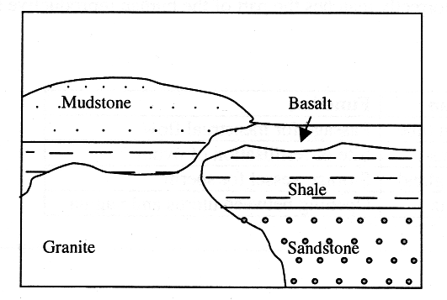

2. Which natural event most likely resulted in the formation of the basalt?

(A) Convection currents in the crust
(B) A cyclone
(C) An earthquake
(D) A volcanic eruption

3. Basalt and granite are both igneous rocks. The mudstone, shale and sandstone are sedimentary rocks.

Which of these rocks is LEAST likely to contain fossils?

(A) Basalt
(B) Mudstone
(C) Sandstone
(D) Shale

4. Chemical substance X occurs naturally in the Earth's crust.

What would make X a useful resource?

(A) Being abundant and occurring in concentrated deposits
(B) Being inexpensive to extract from the crust
(C) Being a renewable resource
(D) Having at least one valuable property

5. Which alternative correctly matches the part of the human reproductive system with its function?

 | Organ | Function
(A) | Fallopian tube | Passage for menstrual flow
(B) | Uterus | Site of fertilisation of ovum
(C) | Prostate gland | Storage vessel for sperm
(D) | Cervix | Opening between uterus and vagina

6. Which of the following statements about pollutants is correct?

(A) A substance that is a pollutant in one environment may not be a pollutant in a different environment.
(B) Any substance that is not natural to an environment is a pollutant in that environment
(C) Pollutants are substances which will not biodegrade in the environment.
(D) Pollutants are the things that people throw away.

7. Using the Hubble space telescope orbiting the earth, astronomers are able to collect more data about the Universe than using land-based telescopes.

What is the best explanation for this?

(A) The Hubble telescope is much closer to other components of the Universe than land based telescopes.
(B) The Hubble telescope is much larger than any land based telescopes.
(C) The Hubble telescope orbits beyond most of the atmosphere.
(D) The Hubble telescope can be used to view any part of the Universe.
Use the following information to answer Questions 8 - 9.

The diagram shows a cross section of part of the Earth's crust. The diagram has been drawn to scale where 1 cm = 100m.

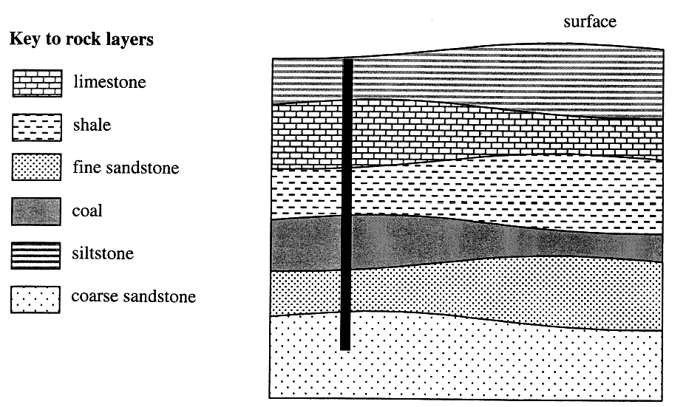

The diagram also shows a bore hole drilled through several layers of rock.

8. What is the thickness of the limestone layer at the point which the bore hole passes through it?

(A) 80m
(B) 120m
(C) 1400m
(D) 1500m

9. According to this data, which rock is older than the limestone and younger than the coal?

(A) Coarse sandstone
(B) Fine sandstone
(C) Shale
(D) Siltstone
Refer to Source A in the stimulus booklet to answer Question 10.

10. Which alternative correctly describes item 5 on the dichotomous key?

(A) Flat base, made of glass, straight sides
(B) Made of glass, legs like scissors
(C) Made of glass, parallel sides, base not flat
(D) Sides not parallel, made of glass, flat base

11. Scientists describe how lightning "strikes" happen as:
- In thunderclouds there is a build up of negative charge in the lower part of the cloud and positive charge in the upper parts of the cloud. Probably caused by water drops rubbing against ice particles.
- A barely visible stream of negative charge snakes down to the ground, called the downstroke.
- This downstroke draws up a streak of positive charge.
- When the two charges meet, they create a short circuit which we see as a flash.

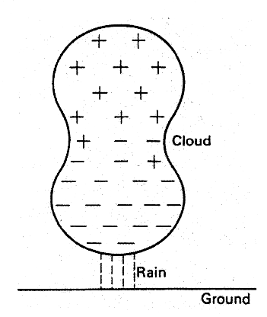

Which aspect of lightning is explained by the diagram above?

(A) Why lightning hits trees
(B) Why thunder occurs with lightning flashes
(C) How clouds rubbing together cause lightning
(D) How positive and negative charge movement results in a lightning flash
Use the diagram below to answer Questions 12 -13.

The diagram shows the different waves of the electromagnetic spectrum and how the wavelength λ and frequency f of the waves are related.

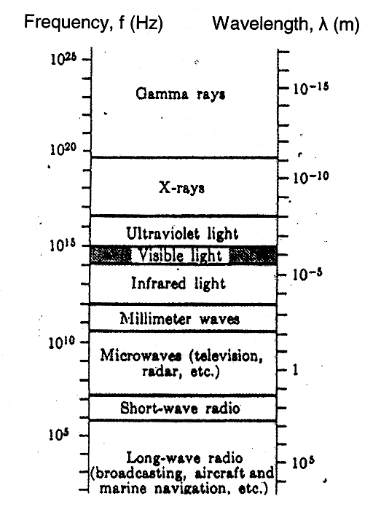

12. Which graph shows how wavelength and frequency are related?

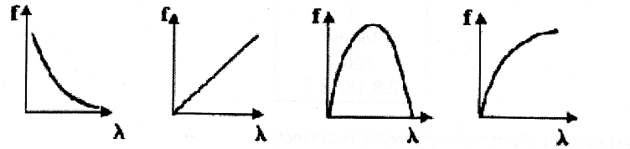
(A) (B) (C) (D)

13. Which electromagnetic waves could be used in industry to check the content levels of closed containers?

(A) Infrared light
(B) Ultraviolet light
(C) X-rays
(D) Visible light
14. Some students wanted to compare the solubilities of three different groups of chemical compounds X, Y and Z.

Which would be the most appropriate hypothesis for their experiment?
(A) The three groups of compounds will have no similarities in solubility.
(B) Some of the compounds in each group will be more soluble than others.
(C) Compounds in group X will be more soluble than compounds in group Y.
(D) Compounds in group X, Y and Z will have decreasing solubilities in that sequence.

Use the following information to answer Questions 15 -16.

The diagram shows a vertical grouping of elements from the Periodic Table.

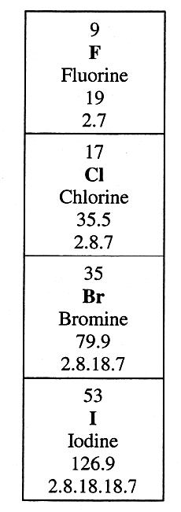

15. Which statement about these elements is correct?

(A) They will have the same chemical properties.
(B) They will have the same physical properties.
(C) They will have similar chemical properties.
(D) They will have very different chemical properties.

16. What is the group name given to these elements?

(A) Alkali metals
(B) Halogens
(C) Inert gases
(D) Non-metals
Use the following information to answer Questions 17 -19.

The diagram below explains a natural disaster.

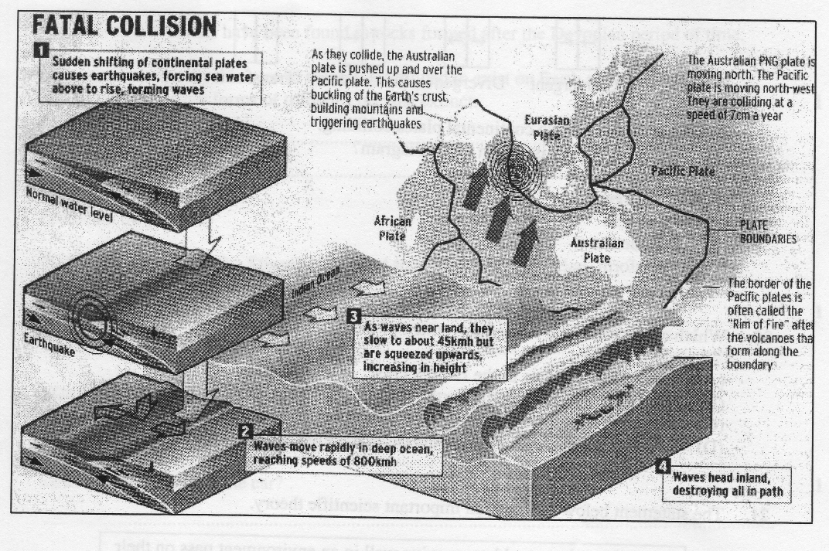
17. What natural disaster is explained in the above diagram?

(A) Flooding
(B) Tsunamis
(C) Cyclones
(D) Volcanic eruptions

18. Based on the above diagram, the coastline of which part of the Australian mainland is the most likely to experience a similar disaster?

(A) Eastern
(B) North-Western
(C) Western
(D) Southern
19. The diagram shows how plate boundaries are classified as one of four types, according to the movement of plates on each side of the boundary.

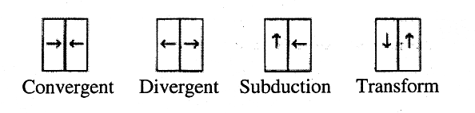

The diagram depicts two continental plates colliding.
What type of boundary is shown in the diagram?

(A) Convergent
(B) Divergent
(C) Subduction
(D) Transform

20. Which of the following causes movement of the Earth's plates?

(A) Convection currents in the Earth's crust
(B) Convection currents in the Earth's mantle
(C) Magnetic forces due to iron in the Earth's core
(D) Magnetic forces due to iron in the earth's mantle

21. The statement below is part of an important scientific theory.

“Organisms that are able to survive well in an environment pass on their characteristics to more offspring and these characteristics become more common.”

What is the name of this theory?
(A) The theory of evolution
(B) The theory of adaptation
(C) Creationism
(D) Lamarks theory
Use the following information to answer Questions 22 - 24.

The table shows two chemical properties of some compounds. 22.

Compound | Reaction with hydrochloric acid | Reaction when heated in air
E | Forms a salt, carbon dioxide and water | Forms an oxide and carbon dioxide
F | Forms a salt and water | Forms an oxide and water
G | Forms a salt and hydrogen gas | No reaction
H | No reaction | No reaction
I | Forms a salt, carbon dioxide and water | Forms an oxide and carbon dioxide
J | Forms a salt, carbon dioxide and water | Forms an oxide and carbon dioxide
K | Forms a salt and water | Forms an oxide and water
L | Forms a salt and hydrogen gas | No reaction
M | Forms a salt, carbon dioxide and water | Forms an oxide and carbon dioxide

22. Which compounds below are most similar?

(A) E and F
(B) G and H
(C) E and J
(D) K and L

23. Which compound is probably calcium hydroxide?

(A) J
(B) K
(C) L
(D) M

24. Which equation best represents the reaction between M and hydrochloric acid?

(A) tin hydroxide + hydrochloric acid  tin chloride + water + carbon dioxide
(B) tin chloride + hydrochloric acid  tin chloride + water + carbon dioxide
(C) tin sulfate + hydrochloric acid  tin chloride + water + carbon dioxide
(D) tin carbonate + hydrochloric acid  tin chloride + water + carbon dioxide
Use the following information to answer Questions 25 - 27.

The hormone insulin controls the sugar level in the blood. When the blood glucose level rises above normal, more insulin is produced. This acts on the liver, where excess glucose is removed from the blood and converted to glycogen. If the blood glucose falls below normal, insulin production falls and glycogen in the liver is changed back to glucose.

The following incomplete flow diagram summarises the feedback loop for control of insulin in the blood.

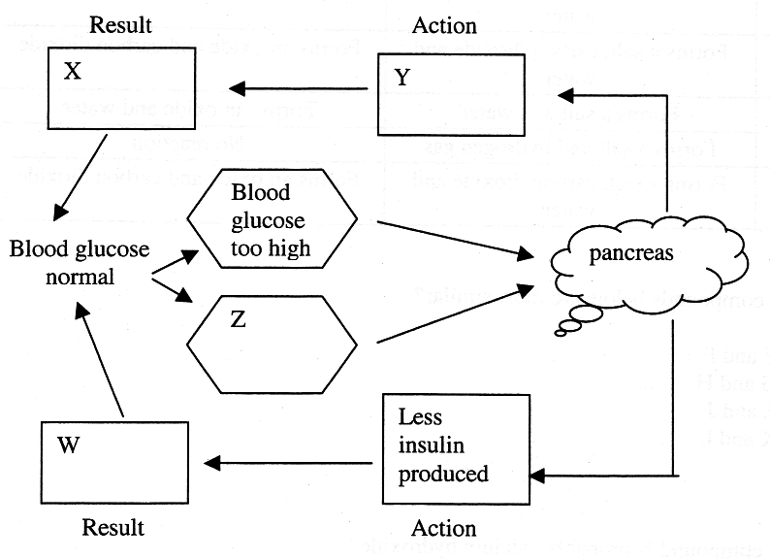

25. Which alternative fits in the box labelled X?

(A) The liver converts glycogen to glucose
(B) The liver converts glucose to glycogen
(C) The pancreas produces more insulin
(D) The pancreas converts glucose to glycogen

26. The pancreas is an organ in the endocrine system of the human body.

Which alternative is the best description of the function of the endocrine system?

(A) Controlling the contents of the blood
(B) All co-ordination in the human body.
(C) Control of metabolism, reproduction, growth and development
(D) Production of hormones to regulate the menstrual cycle
27. In a feedback loop, information about the result of an action is communicated to the control centre responsible for initiating the action.
Which organ is the control centre for the feedback loop described above?

(A) The brain
(B) The liver
(C) The blood
(D) The pancreas

Refer to Source B in the Stimulus Booklet to answer Questions 28 - 29.

28. Which two fossils, if present in sedimentary rock, would indicate that the rock must have been formed during the Ordovician period?

(A) Fossils 6 and 7
(B) Fossils 6 and 8
(C) Fossils 7 and 8
(D) Fossils 7 and 9

29. Which statement is best justified by the information in the diagram?

(A) Trilobite fossils have been present in rocks since Pre-Cambrian times.
(B) Trilobites were only on Earth for a very limited period of time.
(C) Trilobites are a recently evolved type of life on Earth.
(D) Trilobites were most varied on Earth during the Ordovician period.

30. Which characteristic makes possible the growth, repair and reproduction of all multicellular organisms?

(A) Meiosis
(B) Cell division
(C) Absorption of oxygen
(D) Production of carbon dioxide
31. The diagram below shows information about one of the elements on the Periodic Table.

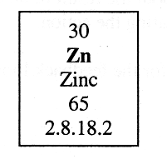

Which statement about the number of protons and electrons in this element is correct?

 | Number of protons | Number of electrons
(A) | 30 | 30
(B) | 30 | 35
(C) | 35 | 30
(D) | 35 | 35

Refer to Source C in the stimulus booklet to answer Question 32.

32. In which alternative does the part of the blood match the description?

 | Part of blood | Description
(A) | Erythrocytes | White blood cells made in the bones
(B) | Platelets | Engulf and destroy bacteria
(C) | Plasma | Mostly water with dissolved substances
(D) | White blood cells | Help clot the blood

Use the following information to answer Questions 33 - 34.

The diagrams below show the proportions of three minerals in three different rocks of equal mass.

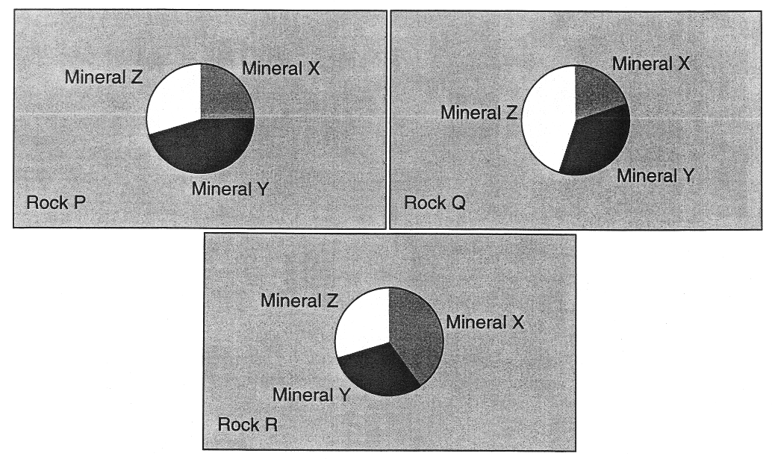

33. Which statement about these rocks is correct?

(A) Rock P has more mineral X than rock Q.
(B) Rock Q has less mineral Z than rock R.
(C) Rock R has more mineral Y than rock P.
(D) Rock R has more mineral Y than rock Q.

34. What is the approximate percentage of mineral X in rock P?

(A) 33
(B) 25
(C) 40
(D) 45

35. Which choice correctly shows the development sequence of a star?

(A) Nebula, hydrogen fusion star, blue giant, white dwarf
(B) Hydrogen fusion star, helium fusion star, white dwarf, black hole
(C) Protostar, hydrogen fusion star, red giant, white dwarf
(D) Nebula, protostar, hydrogen fusion star, supernova, black dwarf
36. The picture below shows a component of the Universe

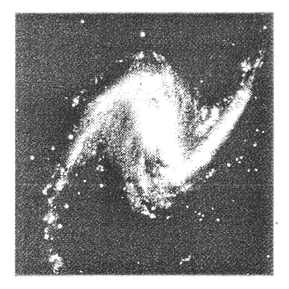

What is this component called?

(A) A small star
(B) A giant star
(C) A comet
(D) A galaxy

Refer to Source D in the stimulus booklet to answer Questions 37 - 38.

37. How far will the car have travelled at point X?

(A) 38 units
(B) 40 units
(C) 48 units
(D) 56 units

38. A truck of twice the car's mass was moved in the same way.

What would need to be different for this to happen?

(A) The frictional force applied to the truck would need to be larger.
(B) The weight of the truck would be twice that of the car.
(C) The force applied would need to be twice as large.
(D) Nothing different would need to happen.
39. Diamonds are a rare natural resource. They are often used on drills that bore holes through rock. What is the reason for using diamond in this way?

(A) Diamond is harder than all minerals other than topaz.
(B) Diamond is the hardest natural substance.
(C) It is only the small, and otherwise useless diamond chips that are used.
(D) They can be recycled for other uses later.

Use the following information to answer Question 40

The statements below were part of a media report.

The Australian Government has been advised that global temperatures will rise three times as much as many scientists had previously estimated, resulting in irreversible changes for life on Earth.

A report commissioned from the Australian National University showed that global warming would push temperatures up by as much as 5.8 degrees celcius by 2100.

40. What is the main cause of global warming?

(A) The hole in the ozone layer
(B) Increased use of microwave ovens
(C) Manufacture of synthetic materials
(D) Emission of greenhouse gases

41. Which alternative best describes the statement that the temperature will rise by 5.8 degrees?

(A) A well accepted scientific fact
(B) Hypothesis based on analysis of trends in current data
(C) A measurement
(D) An accurate computer generated figure.
42. The diagram below shows three people; Glen, Louise, and Lachlan, standing near two mirrors placed at right angles to each other.

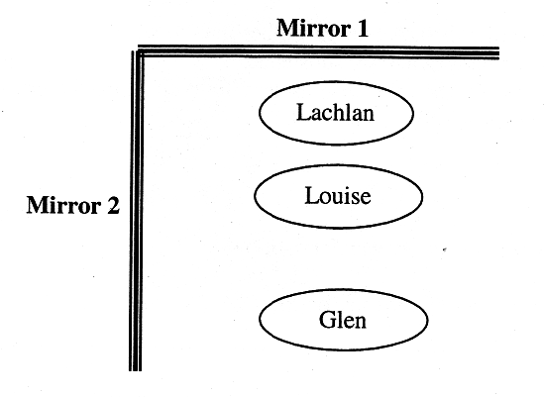

When Louise looks in the mirrors, who is she able to see?

(A) Louise could see Glen by looking in either mirror l or mirror 2 and Lachlan in mirror 1 only.
(B) Louise could see both Lachlan and Glen in mirror 1.
(C) Louise could see both Lachlan and Glen in mirror 2.
(D) Louise could not see anyone except herself in the mirrors.

43. The diagram below shows the distance from the centre of the Sun to Barnard's star. The diagram is drawn to scale.

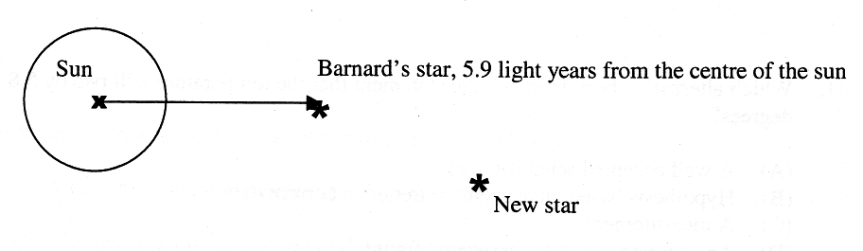

What is the distance to the new star?

(A) 4.4 light years
(B) 8.8 light years
(C) 10.3 light years
(D) 5.9 light years
Use the information below to answer Questions 44 - 45.

Adam dissolved copper sulfate crystals in water to determine the effect of temperature on the mass of the crystals that could be dissolved in 250mL of water. The graph shows his results.

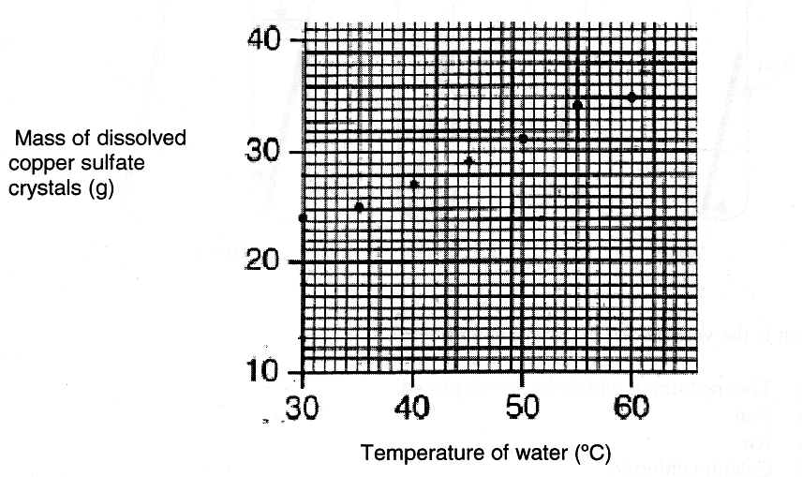

44. Which of the following items of equipment is NOT needed for the experiment?

(A) Stirring rod
(B) Filter funnel
(C) Heat mat
(D) Measuring cylinder

45. The mass reading taken at 55°C appears to be a slight error.
What mass measurement would be predicted by the graph for the reading at 55°C?

(A) 30g
(B) 31g
(C) 33g
(D) 35g
Use the information to answer Questions 46 - 50:

Angela, Brendan and Blair set up the following test tubes to study the factors which affect the rate at which iron rusts in various conditions compared to dry air.

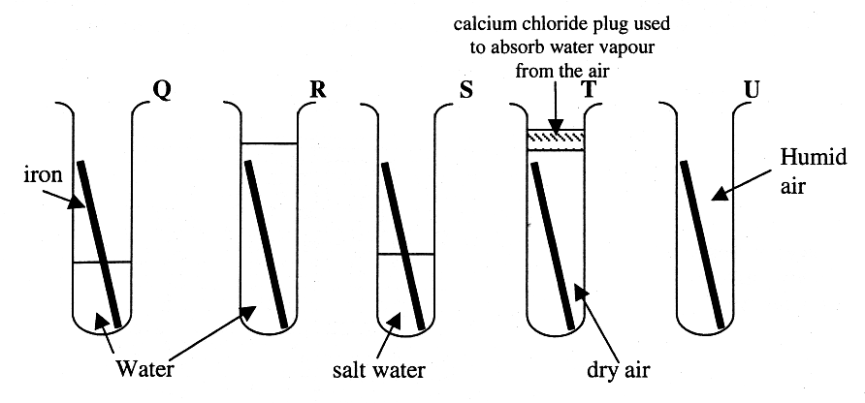

46. What is the variable for the above experiment?

(A) The medium in which the iron is placed
(B) Iron
(C) Air
(D) Calcium chloride

47. What factor is being tested in test tube S?

(A) Water
(B) Air
(C) Air and salt water
(D) Calcium chloride

48. Angela argued that test tube T was the experimental control. Brendan argued that test tube U was the experimental control.

Who is correct and why?

(A) Angela is correct because in test tube T all the factors being tested are absent.
(B) Brendan is correct because the environment in test tube U is just air.
(C) Both Angela and Brendan are correct because this experiment is complicated and needs two experimental controls.
(D) Neither Angela nor Brendan is correct as test tubes T and U both contain at least one of the factors being tested.
Use the information on the previous page and the following to answer Questions 49 - 50.

The table shows the results of the experiment.

Tube | Observations after several days
Q | Significant rust on iron at air/water boundary, slight rust on iron in water, no rust on part of iron in air.
R | Some rust covered the iron.
S | Largest amount of rust observed for this experiment at the salt water/air boundary. Significant rust on part of iron in the salt water, no visible rust on part of iron out of the salt water.
T | No visible rust on iron
U | Slight visible rust on iron

49. Which choice shows the correct order for the factors from greatest to least effect on the iron?
(A) Air and water, salt water alone, water alone
(B) Air and salt water, air and water, water alone
(C) Air and salt water, water alone, air and water
(D) Air and water, salt water alone, air alone

50. Which of the following would be an improvement on the experimental design?

(A) Randomisation
(B) Using different salts
(C) Replication of the experiment
(D) Using different gases
Section I – continued

Part B
Total marks (10)
Attempt Questions 51- 60
Allow about 20 minutes for this part

Answer the questions in the spaces provided on the answer sheet.

Question 51 (1 mark) Marks

Which quantity increases if the voltage through a light globe is raised? 1

………………………………………………………………………………………………………

Question 52 (1 mark)

Are temperature, humidity and air quality, examples of biotic or abiotic environmental
features? 1

Use the information below to answer Questions 53 - 54:

The diagram summarises what happens when the Earth's resources are utilized.

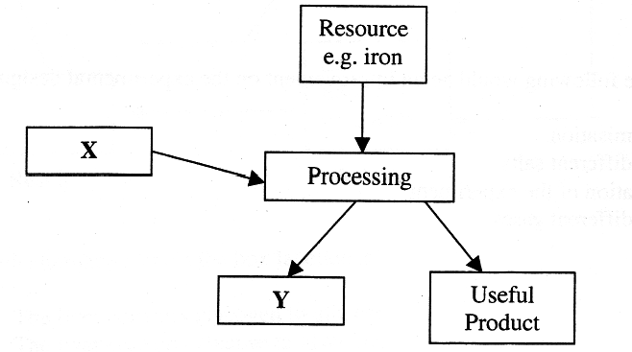
Input

Question 53 (1 mark)

What is X? 1

………………………………………………………………………………………………………

Question 54 (1 mark)

What is Y? 1

………………………………………………………………………………………………………
Question 55 (1 mark) Marks

Refer to Source B in the Stimulus Booklet to answer this Question.

Trilobite type 8 fossils have been found in rocks formed after the Devonian period of time.

Suggest a reason why this type of trilobite continued to exist on Earth after the Devonian
period when all other forms of trilobites became extinct. 1

………………………………………………………………………………………………………
………………………………………………………………………………………………………

Question 56 (1 mark)

Refer to Source C in the Stimulus Booklet to answer this Question.

What is the chemical formula for the gas exhaled from the lungs? 1

………………………………………………………………………………………………………

Question 57 (1 mark)

Refer to Source D in the Stimulus Booklet to answer this Question.

Describe the motion of the car? 1

………………………………………………………………………………………………………
………………………………………………………………………………………………………

Question 58 (1 mark)

What name is given to the smallest unit of an element? 1

………………………………………………………………………………………………………

Question 59 (1 mark)

Why do we use indicators in Chemistry? 1

………………………………………………………………………………………………………

Question 60 (1 mark)
What general name is given to an insoluble chemical which forms when solutions of two
soluble chemicals react with each other? 1

………………………………………………………………………………………………………

End of Section I

Section II

Total marks (40)
Attempt Questions 61 - 67
Allow about 50 minutes for this part

Answer the questions in the spaces provided on this paper.

Question 61 (6 marks) Marks

Refer to Source A in the stimulus booklet to answer this Question.

(a) Draw a scientific diagram of a filter funnel. 2

(b) Which number on the key best represents a conical flask? 1

………………………………………………………………………………………………

Question 61 continues on the next page
Question 61 (continued) Marks

(c) While the dichotomous key can be used to distinguish between a graduated beaker and a measuring cylinder, it is not as good as it could be for this purpose.
In the space below, redesign the relevant section of the key (the starting point is given below) so that it is easier to use to distinguish between a beaker and a measuring cylinder. 3

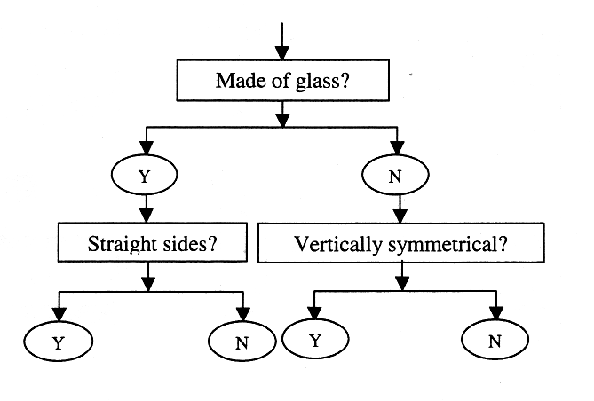

Question 62 (6 marks) Marks

Use the information below answer all parts of Question 62

A student set up an experiment to study the chemical reaction between solutions of chemicals P and Q. Chemical P is blue but the compound PQ is colourless. The diagram shows how the student recorded her observations.

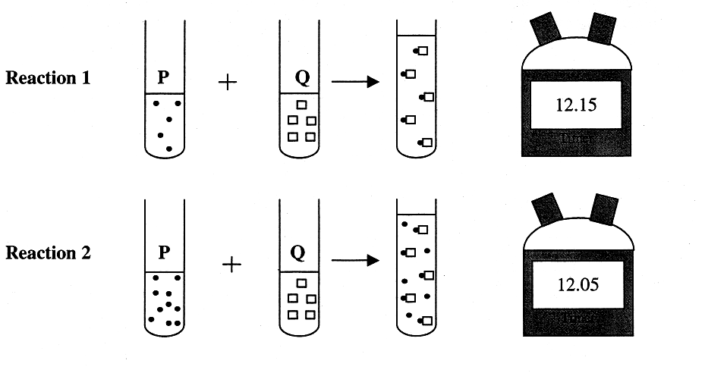

(a) Identify the independent variable in the experiment. 1

………………………………………………………………………………………………

(b) Identify a factor that has been controlled in this experiment. 1

………………………………………………………………………………………………

(c) Suggest an aim for the experiment. 1

………………………………………………………………………………………………

(d) What would be the colour of the final solution in reaction 2. 1

………………………………………………………………………………………………

Question 62 continues on the next page

Question 62 (continued) Marks

(e) Write a conclusion for the experiment. 2

………………………………………………………………………………………………
………………………………………………………………………………………………
………………………………………………………………………………………………
………………………………………………………………………………………………

Question 63 (5 marks)
(a) What is a fossil? 1

………………………………………………………………………………………………
………………………………………………………………………………………………

(b) Describe the conditions under which fossils form. 2
………………………………………………………………………………………………
………………………………………………………………………………………………
………………………………………………………………………………………………
………………………………………………………………………………………………
(c) Outline how geologists use fossils to determine the age of rocks in the Earth's crust. 2

………………………………………………………………………………………………
………………………………………………………………………………………………
………………………………………………………………………………………………
………………………………………………………………………………………………

Question 64 (7 marks) Marks
The diagram shows two "dodgem cars" at a fair ground. The circuit symbol for the motor
in each car is shown.

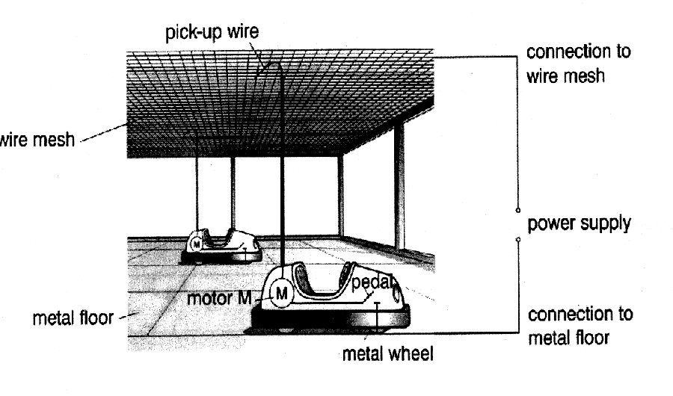
Each “dodgem car” is connected to the power supply through the pick-up wire which is in contact with the wire mesh and through the metal wheel which is in contact with the metal floor.

(a) Are the "dodgem cars" connected in series or parallel to the power supply? 1

………………………………………………………………………………………………
………………………………………………………………………………………………

(b) Explain why the "dodgem cars" will not move until the pedal is pressed even when the
power supply is switched on. 1

………………………………………………………………………………………………
………………………………………………………………………………………………

Question 64 continues on the next page
Question 64 (continued) Marks

(c) Complete the circuit diagram below for the TWO "dodgem cars" using switch symbols and the symbol for the motors of the cars. 2
M

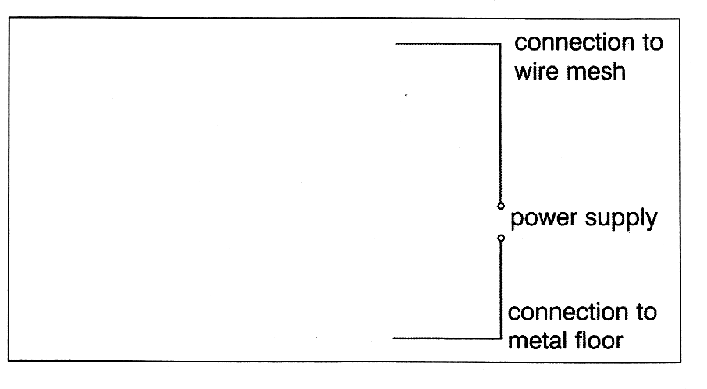

(d) While the two "dodgem cars" are moving, the pick-up wire of one car snaps off. Describe how this affects EACH car and justify your answer in terms of any changes in voltage and current to the motors. 3

………………………………………………………………………………………………
………………………………………………………………………………………………
………………………………………………………………………………………………
………………………………………………………………………………………………
………………………………………………………………………………………………
………………………………………………………………………………………………
Question 65 (4 marks) Marks

Refer to Source C in the stimulus booklet to answer this question.

(a) The diagram represents a flat bottom tube used by nurses when collecting blood from patients.
On the diagram indicate the percentage composition of blood by dividing the tube into sections. 2
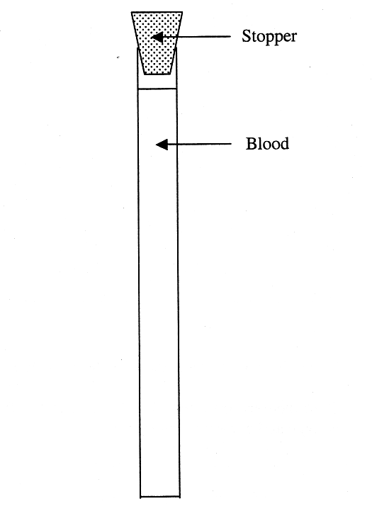

(b) Draw a scale diagram of a leucocyte in the grid below. Identify your scale 2

Question 66 (6 marks) Marks

The genes of every organism are coded on DNA molecules. When a strand of DNA replicates, the 4 nucleotides always pair up - C with G and A with T. The DNA strand ‘unzips’ and free nucleotides find their matches in the two exposed strands. Enzymes then make it possible for the newly attached nucleotides to form into a new strand, that remains attached to one old strand. It is by this method that each new DNA duplex is usually identical in sequence to the old DNA duplex.

(a) Name the scientists who discovered the double helix structure of DNA. 1

………………………………………………………………………………………………

(b) Explain the advantages of DNA replicating exactly. 2

………………………………………………………………………………………………
………………………………………………………………………………………………
………………………………………………………………………………………………
………………………………………………………………………………………………

(c) Why has mutation of DNA been important for life on Earth? 2

………………………………………………………………………………………………
………………………………………………………………………………………………
………………………………………………………………………………………………
………………………………………………………………………………………………
(d) Identify ONE environmental factor responsible for mutation of DNA. 1

………………………………………………………………………………………………
………………………………………………………………………………………………

Question 67 (6 marks) Marks

Refer to Source D in the stimulus booklet to answer this question.

(a) Other than the measurement of point X, what important information is missing from the students’ diagram? 1

………………………………………………………………………………………………

(b) Outline an experiment you have done to study the movement of an object when a force is applied to it. 5

………………………………………………………………………………………………
………………………………………………………………………………………………
………………………………………………………………………………………………
………………………………………………………………………………………………
………………………………………………………………………………………………
………………………………………………………………………………………………
………………………………………………………………………………………………
………………………………………………………………………………………………
………………………………………………………………………………………………
………………………………………………………………………………………………
………………………………………………………………………………………………
………………………………………………………………………………………………
………………………………………………………………………………………………
………………………………………………………………………………………………

