School Certificate 2009
Revision Questions
Physics

- This set of questions comes from the School Certificate Science Test 2009. The highlighted section indicates which questions are included.

- Please use the separate Answer Booklet when recording your answers.

- This set of questions should be returned to your class teacher without any additions or alterations.

Section A Physics

Multiple Choice 2, 6, 18, 34, 38
Short Answer 51, 52, 53, 55
Longer Answer 64

Section B Biology

Multiple Choice 8, 9, 10, 22, 28, 36, 37
Short Answer 58
Longer Answer 66, 67, 68

Section C Chemistry

Multiple Choice 3, 4, 5, 13, 14, 19, 26, 27, 29, 30
Short Answer 54, 57

Section D Geology and Processing Information

Multiple Choice 1, 7, 11, 12, 15, 16, 17, 20, 21, 23, 24, 25, 31, 32, 33, 35
Short Answer 56
Longer Answer 65

Section E Stimulus Booklet

Multiple Choice 39, 40, 41, 42, 43, 44, 45, 46, 47, 48, 49, 50
Short Answer 59, 60
Longer Answer 61, 62, 63

School Certificate Examination 2009

Set A : Physics Questions

Question 2

What is one use for X-rays?

A. Scanning barcodes
B. Home alarm systems
C. Operating remote controls
D. Making images of skeletons

Question 6

Mobile phones use microwaves to send information to a transmitter.
What type of energy is used to carry the information from the mobile phone to a transmitter?

A. Electromagnetic
B. Heat
C. Light
D. Sound

Question 18

The diagrams show two equal forces acting on a 10 kg mass in different ways.
Which arrangement of forces will lead to the greatest acceleration of the 10 kg mass?

Question 34

What is the frequency of a wave?

A. The speed of the wave
B. The direction of the wave
C. The distance between wave crests
D. The number of vibrations each second

Question 38

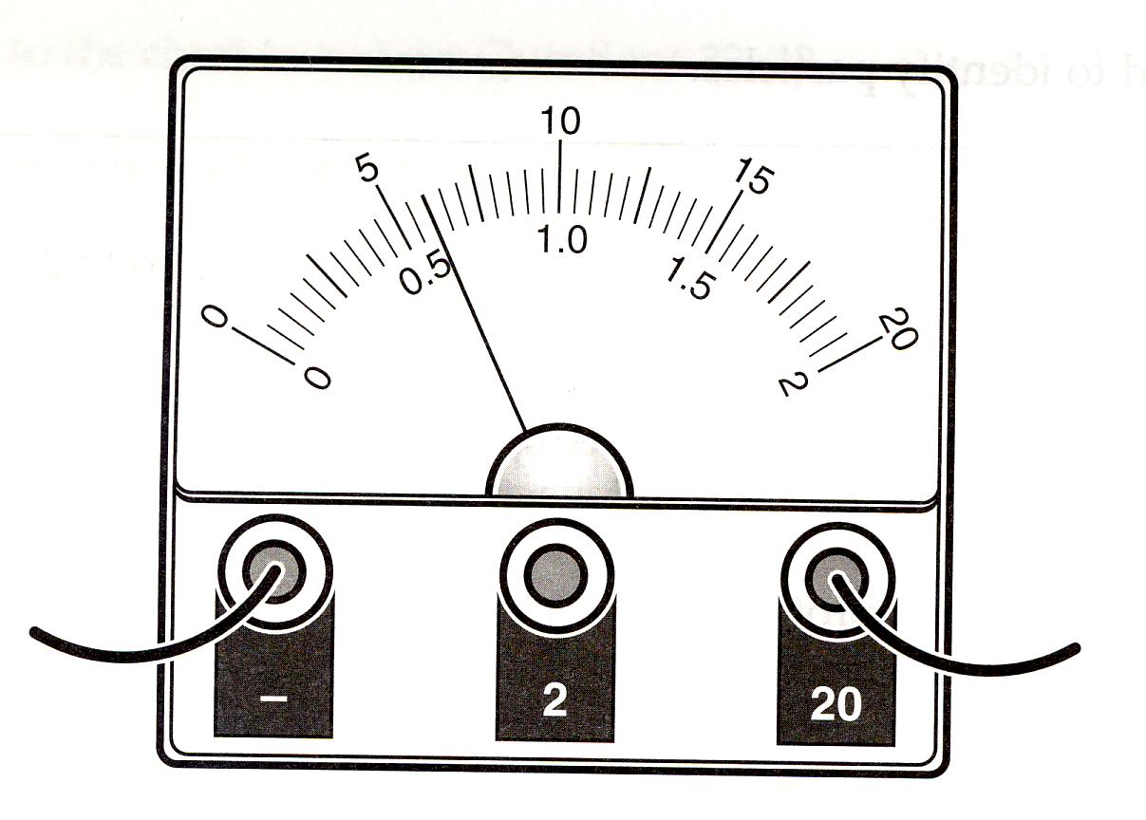

What is the reading on the voltmeter?

A. 0.52 V
B. 0.6 V
C. 5.2 V
D. 6.0 V

Refer to the following graph to answer Questions 51–53.
The graph represents a student’s progress walking from school to home over 20 minutes.

Question 51

How many metres did the student travel to get home?

Question 52

How many times did the student stop during the journey?

Question 53

What was the student’s average speed for the first 4 minutes in metres per minute?
distance
speed = ------------
time

Question 55

What is the name given to the current scientific theory to explain how the universe began?

Question 64 (3 marks)

The diagrams illustrate the effect of gravity on a 70 kg astronaut on the Moon and on Earth. The size of the arrows is an indication of the difference in gravity (newtons) at each place.

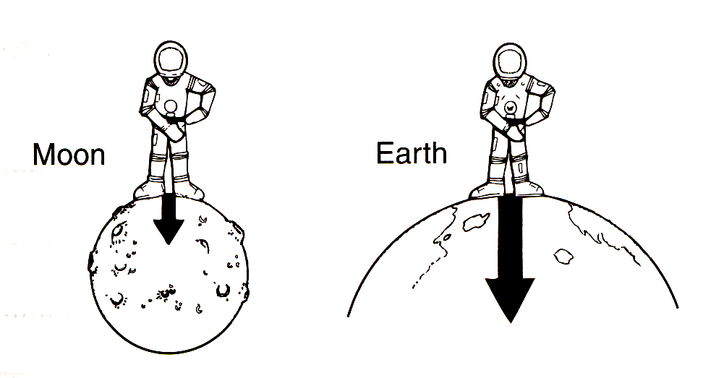

Referring to the diagram, distinguish between the terms mass and weight.

