School Certificate 2007
Revision Questions
Physics

- This set of questions comes from the School Certificate Science Test 2007. The highlighted section indicates which questions are included.

- Please use the separate Answer Booklet when recording your answers.

- This set of questions should be returned to your class teacher without any additions or alterations.
Section A Physics

Multiple Choice 4, 6, 7, 12, 13, 17, 19, 20, 33, 34, 35, 36, 37, 38
Short Answer 51
Longer Answer

Section B Biology

Multiple Choice 2, 10, 11, 14, 15, 16, 22
Short Answer
Longer Answer 64

Section C Chemistry

Multiple Choice 3, 8, 21, 27, 28, 29, 30, 31
Short Answer 52
Longer Answer

Section D Geology and Miscellaneous

Multiple Choice 1, 5, 9, 18, 23, 24, 25, 26, 32, 39, 40, 41, 42, 43
Short Answer
Longer Answer 62

Section E Stimulus Booklet

Multiple Choice 44, 45, 46, 47, 48, 49, 50
Short Answer 53, 54, 55, 56, 57, 58, 59, 60
Longer Answer 61, 63, 65

School Certificate Examination 2007

Set A : Physics Questions

Question 4

The diagram shows a method of capturing light energy from the Sun.
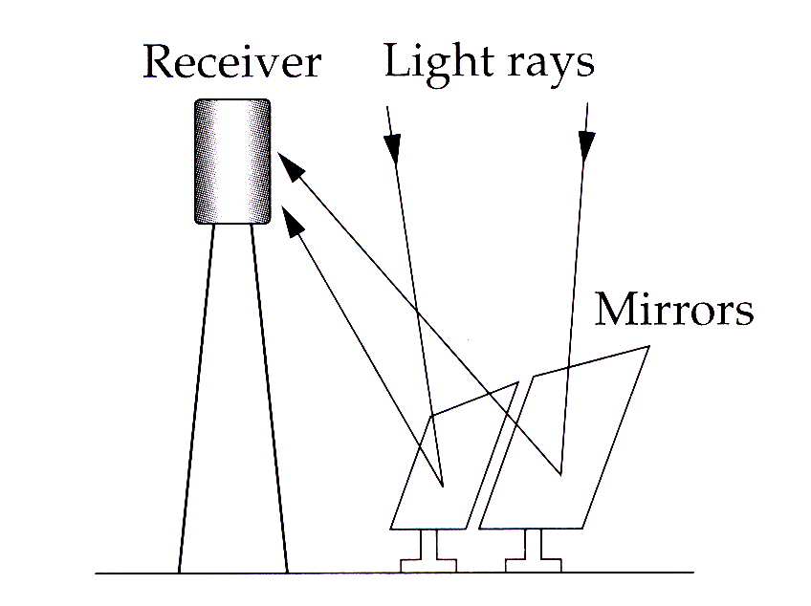

Which property of light is being used to direct the light onto the receiver?

A. Absorption
B. Conduction
C. Reflection
D. Refraction

Use the information to answer Questions 6 and 7.

In a circuit, the relationship between the voltage, current and resistance can be written as:

Voltage (V) = Current (I) × Resistance (R)

Question 6

When a circuit becomes hot the resistance increases.

What will happen as a result?

A. Current and voltage will both increase.
B. Current will decrease if the voltage remains the same.
C. Voltage and current will remain the same.
D. Voltage will decrease if the current remains the same.

Question 7

If the current in a circuit is 6 amperes and the resistance is 4 ohms, what is the voltage?

A. 2 volts
B. 10 volts
C. 24 volts
D. 30 volts
Use the information to answer Questions 12 and 13.

A student wanted to investigate how the acceleration of a trolley was affected by the mass of the trolley. He set up the trolley on a bench and used masses hung over a pulley to provide a force on the trolley.

Question 12

Which variable should the student change during the experiment?

A. The number of masses carried on the trolley
B. The number of masses hanging from the pulley
C. The distance that the trolley travels along the bench
D. The distance that the masses hang below the pulley

Question 12

The student measured how long it took the trolley to travel from rest along the bench.

How would his measurements be related to the acceleration of the trolley?

A. If the time decreased, the acceleration would halve.
B. If the time increased, the acceleration would increase.
C. If the time increased, the acceleration would decrease.
D. If the time decreased, the acceleration would be constant.

Question 17

The diagram shows four light waves drawn to the same scale.

Which statement about the waves is correct?

A. P and R have the same energy but different frequencies.
B. R and S have the same energy but different frequencies.
C. Q and S have different energy but the same frequency.
D. P and Q have the same energy and the same frequency.

Question 19

The diagram shows two types of telescope.
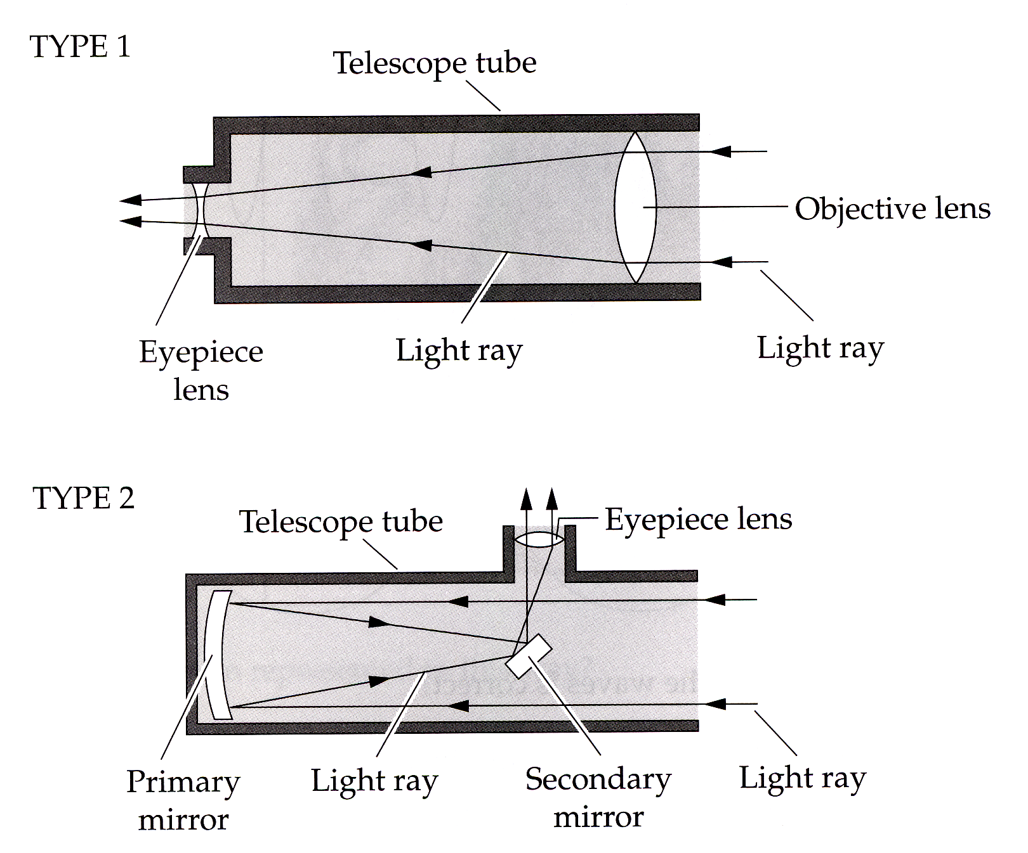

What is the main difference between these two types of telescope?

A. Type 1 uses refraction and Type 2 uses reflection.
B. Type 1 uses reflection and Type 2 uses refraction.
C. Type 1 focuses light but Type 2 does not.
D. Type 1 does not focus light but Type 2 does.

Question 20

The skateboard rider shown in the time-lapse photograph is performing an ‘ollie’.

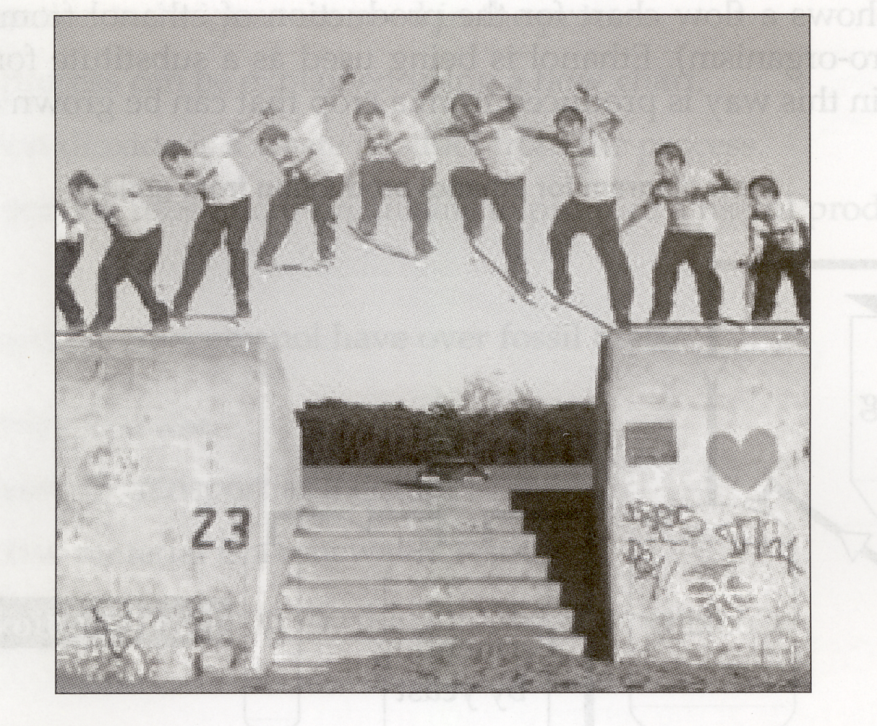

During this mid-air move the skater is able to manipulate his legs so that the board appears to stick to his feet.

Which scientific principle appears to have been broken?

A. Acceleration
B. Conservation of mass
C. Gravity
D. Wave motion

Question 33

A security alarm uses a sensor that measures the amount of infrared radiation reaching it. The alarm is set off when a warm object enters the room and an increase in infrared radiation is detected. It is possible to stop the alarm working by placing a sheet of clear glass in front of the sensor.

What is the most likely reason for the glass having this effect?

A. The glass absorbs the infrared radiation.
B. The glass reflects the infrared radiation.
C. The glass absorbs visible light and gives off infrared radiation.
D. The infrared radiation has to travel around the edges of the glass.

Question 34

Which of the following factors makes it difficult for astronomers to gather information about the Universe?

A. Sound produced by aeroplanes
B. The number of stars in the sky
C. Light from towns and cities
D. Radiowaves from space
Question 35

A ball is rolled down a smooth slope and its acceleration is measured.

Which graph shows the acceleration of the ball?

Question 36

The characteristics of two different electric light bulbs were measured and are shown in the table.

If Bulb 1 and Bulb 2 were then connected into a parallel circuit, how would they compare?

A. Neither bulb would light up.
B. Both bulbs would be equally bright.
C. Bulb 1 would be brighter than Bulb 2.
D. Bulb 2 would be brighter than Bulb 1.

Question 37

What is the most widely held scientific theory about the origin of the Universe?

A. Oscillating Model
B. Plate Tectonics
C. Steady State
D. Big Bang

Question 38

Police use two types of speed detection devices in NSW:

RADAR – stands for ‘RAdio Detection And Ranging’, and

LIDAR – stands for ‘LIght Detection And Ranging’, commonly known as a ‘laser gun’.

Which speed detection device uses electromagnetic radiation?

A. LIDAR
B. RADAR
C. Both devices
D. Neither device

Question 51

What is the wavelength in millimetres of the wave shown?

