School Certificate 2009
Revision Questions
Biology

- This set of questions comes from the School Certificate Science Test 2009. The highlighted section indicates which questions are included.

- Please use the separate Answer Booklet when recording your answers.

- This set of questions should be returned to your class teacher without any additions or alterations.

Section A Physics

Multiple Choice 2, 6, 18, 34, 38
Short Answer 51, 52, 53, 55
Longer Answer 64
Section B Biology

Multiple Choice 8, 9, 10, 22, 28, 36, 37
Short Answer 58
Longer Answer 66, 67, 68

Section C Chemistry

Multiple Choice 3, 4, 5, 13, 14, 19, 26, 27, 29, 30
Short Answer 54, 57

Section D Geology and Processing Information

Multiple Choice 1, 7, 11, 12, 15, 16, 17, 20, 21, 23, 24, 25, 31, 32, 33, 35
Short Answer 56
Longer Answer 65

Section E Stimulus Booklet

Multiple Choice 39, 40, 41, 42, 43, 44, 45, 46, 47, 48, 49, 50
Short Answer 59, 60
Longer Answer 61, 62, 63,

School Certificate Examination 2009

Set B : Biology Questions

Use the diagram to answer Questions 8–10.

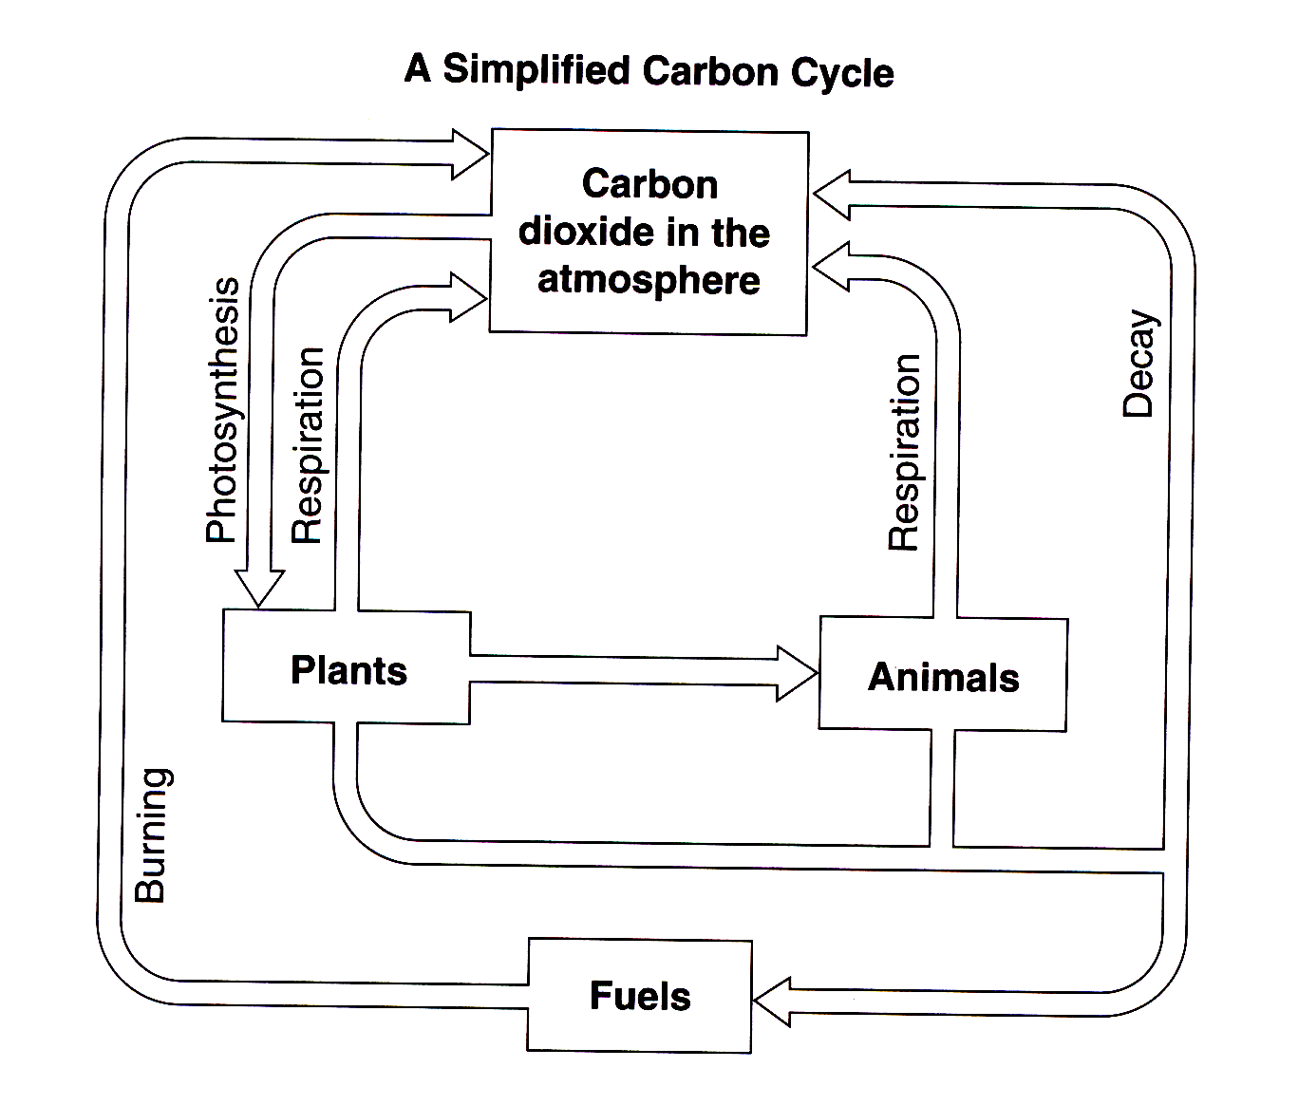

Question 8

Which process involves plants using carbon dioxide?

A. Burning
B. Decay
C. Photosynthesis
D. Respiration

Question 9

Which processes add carbon dioxide to the atmosphere?

A. Burning, decay and respiration
B. Burning, decay and photosynthesis
C. Respiration, decay and photosynthesis
D. Burning, photosynthesis and respiration

Question 10

Organisms involved in decay are called decomposers.
What role do decomposers play in the carbon cycle?

A. They provide food for animals.
B. They allow carbon to be reused.
C. They limit the number of plants in an ecosystem.
D. They remove carbon dioxide from the atmosphere.
Question 22

The diagram shows a DNA molecule.

What is the name of the section labelled P on the DNA molecule?

A. base
B. chromosome
C. gene
D. nucleus

Question 28

Which two scientists are given credit for describing the structure of DNA?

A. Darwin and Wallace
B. Fleming and Florey
C. Newton and Mendel
D. Watson and Crick

What is an advantage of DNA mutating?

Question 36

A. DNA is altered.
B. Mutations cause deformities.
C. Mutations give rise to variation.
D. DNA mutations are essential for transportation of materials.

Question 37

When cells divide to replace dead skin cells the DNA is replicated exactly.
What advantage does this give the new cells?

A. They will be more resistant to ultraviolet light.
B. They will last longer than the ones they replace.
C. They will be stronger than the ones they replace.
D. They will perform the same functions as the ones they replace.

Question 58

What name do we give to any type of disease that can be passed from one person to another person?

Question 66 (7 marks)

(a) Complete the flowchart to summarise the process of natural selection and its effect on a species.
Use as many boxes as you require.

(b) Name a scientific theory and explain how a specific piece of evidence supports this theory.
(3 marks)

Question 67 (5 marks)

The diagram shows the human reproductive systems.

(a) Complete the table for the organs labelled X and Y. (3 marks)

(b) Identify the organ labelled Z and describe its reproductive function. (2 marks)

Question 68 (7 marks)

Some alternative energy sources are nuclear energy, wind energy and solar energy. Evaluate the environmental impacts of replacing fossil fuels with alternative energy sources.

