School Certificate 2008
Revision Questions
Biology

- This set of questions comes from the School Certificate Science Test 2008. The highlighted section indicates which questions are included.

- Please use the separate Answer Booklet when recording your answers.

- This set of questions should be returned to your class teacher without any additions or alterations.

Section A Physics

Multiple Choice 16, 17, 23, 26, 27, 28, 39
Short Answer
Longer Answer 61
Section B Biology

Multiple Choice 2, 25, 31, 32, 33, 34, 37, 40
Short Answer 51, 52
Longer Answer 68

Section C Chemistry

Multiple Choice 1, 4, 5, 7, 20, 21, 22, 29, 30, 35, 36, 38, 41

Section D Geology and Miscellaneous

Multiple Choice 3, 6, 8, 9, 10, 11, 12, 13, 14, 15, 18, 19, 24
Short Answer 57, 58, 59, 60
Longer Answer 63, 66

Section E Stimulus Booklet

Multiple Choice 42, 43, 44, 45, 46, 47, 48, 49, 50
Short Answer 53, 54, 55, 56
Longer Answer 62, 64, 65, 67

School Certificate Examination 2008

Set B : Biology Questions

Question 2

Which process has a role in the growth and repair of tissue in multicellular organisms?

A. Coordination
B. Cell division
C. Mutation
D. Sexual reproduction
Question 25

Which group contains only biotic features of the environment?

A. Rocks, soil, air
B. Fungi, soil, rocks
C. Plants, bacteria, air
D. Plants, fungi, bacteria

Question 31

Where is DNA found in the cell?

A. In the genes
B. In the nucleus
C. In the membrane
D. In the cytoplasm

Question 32

In which organ are sperm produced?

A. The penis
B. The prostate gland
C. The scrotum
D. The testes

Question 33

What happens to DNA as a result of a mutation?

A. It unwinds.
B. It splits in two.
C. It replicates exactly.
D. It is not identical to the original.

Question 34

Sheep frequently give birth to twins. Identical twins grow up to be different sizes when adults.

What is the main cause of this difference?

A. Environmental factors
B. Genetic differences between the twins
C. A combination of genetic and environmental factors
D. Nothing to do with genetic or environmental factors

Question 37

Which is the best explanation of the greenhouse effect?

A. A decrease in carbon dioxide in the atmosphere traps more heat and allows more ultraviolet radiation to reach Earth’s surface.
B. An increase in the ozone layer decreases the amount of ultraviolet radiation that reaches Earth’s surface.
C. A decrease in the ozone layer allows more radiation to reach Earth’s surface.
D. An increase in carbon dioxide in the atmosphere traps more heat radiation from Earth.

Question 40

The diagram shows the differences in beak shape among different finch species.

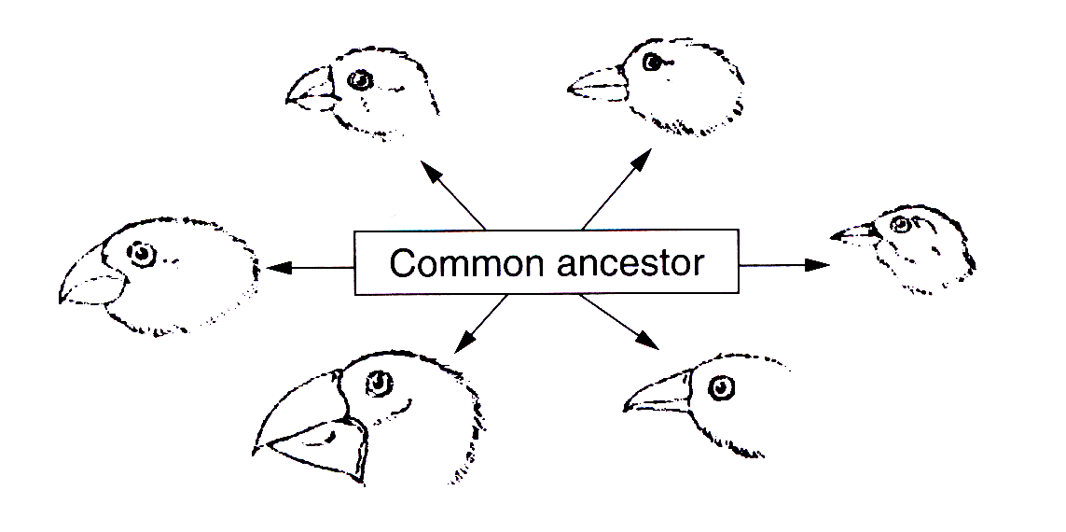

Which process caused the development of these species?

A. Asexual reproduction
B. Ecological cycles
C. Migration
D. Natural selection

Use this diagram to answer Questions 51–52.

Question 51

Which letter correctly labels the ovary?

Question 52

Which letter correctly labels the site where the embryo develops?

Question 68 (7 marks)

A significant issue facing Australia is the provision of adequate water supplies. Some strategies to address this issue that have been discussed in the media are:

• increasing water storage
• decreasing water usage
• increasing water collection options
• recycling.

Describe TWO environmental problems associated with any of the strategies listed above and identify a suitable strategy for providing water in the future, giving reasons for your choice.

