School Certificate 2008
Revision Questions
Chemistry

- This set of questions comes from the School Certificate Science Test 2008. The highlighted section indicates which questions are included.

- Please use the separate Answer Booklet when recording your answers.

- This set of questions should be returned to your class teacher without any additions or alterations.

Section A Physics

Multiple Choice 16, 17, 23, 26, 27, 28, 39
Short Answer
Longer Answer 61

Section B Biology

Multiple Choice 2, 25, 31, 32, 33, 34, 37, 40
Short Answer 51, 52
Longer Answer 68
Section C Chemistry

Multiple Choice 1, 4, 5, 7, 20, 21, 22, 29, 30, 35, 36, 38, 41

Section D Geology and Miscellaneous

Multiple Choice 3, 6, 8, 9, 10, 11, 12, 13, 14, 15, 18, 19, 24,
Short Answer 57, 58, 59, 60
Longer Answer 63, 66

Section E Stimulus Booklet

Multiple Choice 42, 43, 44, 45, 46, 47, 48, 49, 50
Short Answer 53, 54, 55, 56
Longer Answer 62, 64, 65, 67

School Certificate Examination 2008

Set C : Chemistry Questions

Question 1

Where are protons and neutrons located in an atom?

A. In the nucleus
B. As part of the electron cloud
C. As a pair attached to electrons
D. Distributed equally throughout the atom

Question 4

The burning of coal in power stations produces carbon dioxide.

Which chemical reaction produces the carbon dioxide?

A. Acidification
B. Combustion
C. Decomposition
D. Neutralisation

Question 5

What occurs when a new compound is formed?

A. Atoms are lost.
B. Energy is destroyed.
C. New matter is created.
D. Atoms are rearranged.

Question 7

The human stomach contains acid. Sodium bicarbonate (NaHCO₃) is often found as a component of antacids, which are used to settle upset stomachs. It reacts in a similar way to normal carbonates, causing people to burp.

Why does sodium bicarbonate make people burp?

A. It produces hydrogen gas.
B. It solidifies in the stomach.
C. It produces carbon dioxide gas.
D. It settles on top of the stomach contents.

Use the information to answer Questions 20–22.

The table represents part of a row of a simplified Periodic Table.

The following information can be gathered from the table.

Question 20

How many protons are in the atom of oxygen (O) shown?

A. 6
B. 8
C. 16
D. 24

Question 21

How many neutrons are in the atom of fluorine (F) shown?

A. 9
B. 10
C. 19
D. 28

Question 22

On what basis are elements arranged from left to right across a row of the Periodic Table?

A. The atoms gain a proton.
B. The atoms lose two protons.
C. The atoms lose a neutron.
D. The atoms gain two neutrons.

Use the following information to answer Questions 29–30.

This label appeared on a bottle of zinc acetate.

Question 29

Which elements make up zinc acetate?

A. zinc and acetate
B. zinc, acetate and water
C. zinc, carbon, hydrogen and oxygen
D. zinc, carbon, helium, oxygen and water

Question 30

Which of the following safety equipment is the most important when using zinc acetate in a laboratory?

A. Gloves
B. Lab coat
C. Fire blanket
D. Safety goggles

Question 35

Choose the example of a neutralisation reaction.

A. Sodium hydroxide + hydrochloric acid →sodium chloride + water
B. Calcium carbonate →calcium oxide + carbon dioxide
C. Lead nitrate + potassium iodide→ lead iodide + potassium nitrate
D. Methane + oxygen→ carbon dioxide + water

Question 36

The scale shows the reactivity of various metals.

Which metal is more reactive than lead but less reactive than aluminium?

A. Copper
B. Magnesium
C. Sodium
D. Tin

Question 38

A student was studying chemicals found in the kitchen and noted that tea and coffee are both clear brown fluids. If lemon juice is added to both, the tea turns an orange colour but the coffee does not.

Based on these results, which conclusion is correct?

A. Tea acts as an indicator.
B. Coffee acts as an indicator.
C. Both tea and coffee act as indicators.
D. Neither tea nor coffee acts as an indicator.

Question 41

Two different models that attempt to explain the structure of the atom are shown.

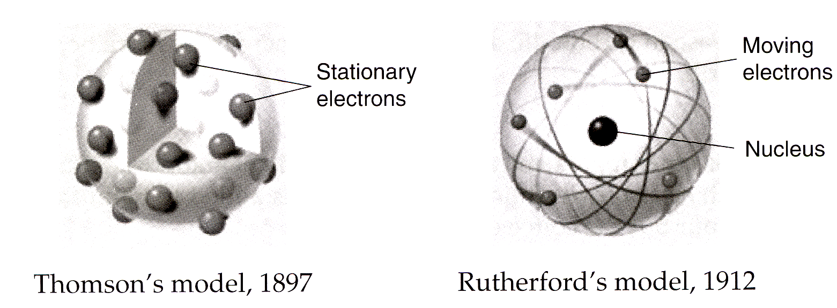

Why is Rutherford’s model considered to be a more accurate representation of the structure of the atom?

A. It suggests that atoms are solid spheres.
B. It suggests that electrons orbit the nucleus.
C. It suggests that electrons are negatively charged.
D. It suggests the location of neutrons in the nucleus.

