School Certificate 2009
Revision Questions
Geology and Processing Information

- This set of questions comes from the School Certificate Science Test 2009. The highlighted section indicates which questions are included.

- Please use the separate Answer Booklet when recording your answers.

- This set of questions should be returned to your class teacher without any additions or alterations.

Section A Physics

Multiple Choice 2, 6, 18, 34, 38
Short Answer 51, 52, 53, 55
Longer Answer 64

Section B Biology

Multiple Choice 8, 9, 10, 22, 28, 36, 37
Short Answer 58
Longer Answer 66, 67, 68

Section C Chemistry

Multiple Choice 3, 4, 5, 13, 14, 19, 26, 27, 29, 30
Short Answer 54, 57

Section D Geology and Processing Information

Multiple Choice 1, 7, 11, 12, 15, 16, 17, 20, 21, 23, 24, 25, 31, 32, 33, 35
Short Answer 56
Longer Answer 65

Section E Stimulus Booklet

Multiple Choice 39, 40, 41, 42, 43, 44, 45, 46, 47, 48, 49, 50
Short Answer 59, 60
Longer Answer 61, 62, 63

School Certificate Examination 2009

Set D : Geology and Processing Information

Question 1

What is the most appropriate piece of equipment to accurately measure 85 mL of water?

(A) 10 mL measuring cylinder
(B) 100 mL measuring cylinder
(C) 100 mL beaker
(D) 250 mL beaker

Question 7

Six steps are involved in applying a scientific process to a problem. In the box below, each step has been given a number, but the steps are not in the correct sequence.

What is the correct sequence of steps?

(A) 1, 3, 6, 5, 4, 2
(B) 5, 3, 6, 1, 4, 2
(C) 5, 6, 3, 1, 2, 4
(D) 3, 5, 1, 6, 4, 2

Use the graph to answer Questions 11–12.
The graph shows the number of sunspots observed over a number of years.

Question 11

In which year were the most sunspots observed?

(A) 1770
(B) 1782
(C) 1789
(D) 1802

Question 12

What is the approximate number of years between the peaks of the graph?

(A) 20
(B) 40
(C) 175
(D) 200
Refer to the diagram to answer Questions 15–17.
The diagram shows the distribution of plant communities in an ecosystem.

Question 15

What is the best way to record the numbers and types of plants found in eacharea?

Question 16

What is the height of the tallest eucalypt?

(A) 18 m
(B) 26 m
(C) 34 m
(D) 840 m

Question 17

Which area of the ecosystem shows ONLY abiotic features?

(A) W
(B) X
(C) Y
(D) Z

Use this information to answer Questions 20–21.
Students set up an experiment to see how temperature affects a chemical reaction. Four 2 cm strips of magnesium were placed into four test tubes of acid at different temperatures as shown.

The students timed in seconds how long it took for the magnesium to dissolve. The results are shown in the table.

Question 20

Which alternative correctly identifies the independent and dependent variables in the experiment?

Question 21

Which graph best represents the results of the experiment?

Use the flowchart to answer Questions 23–25.
The process of making wine is outlined in the flowchart.
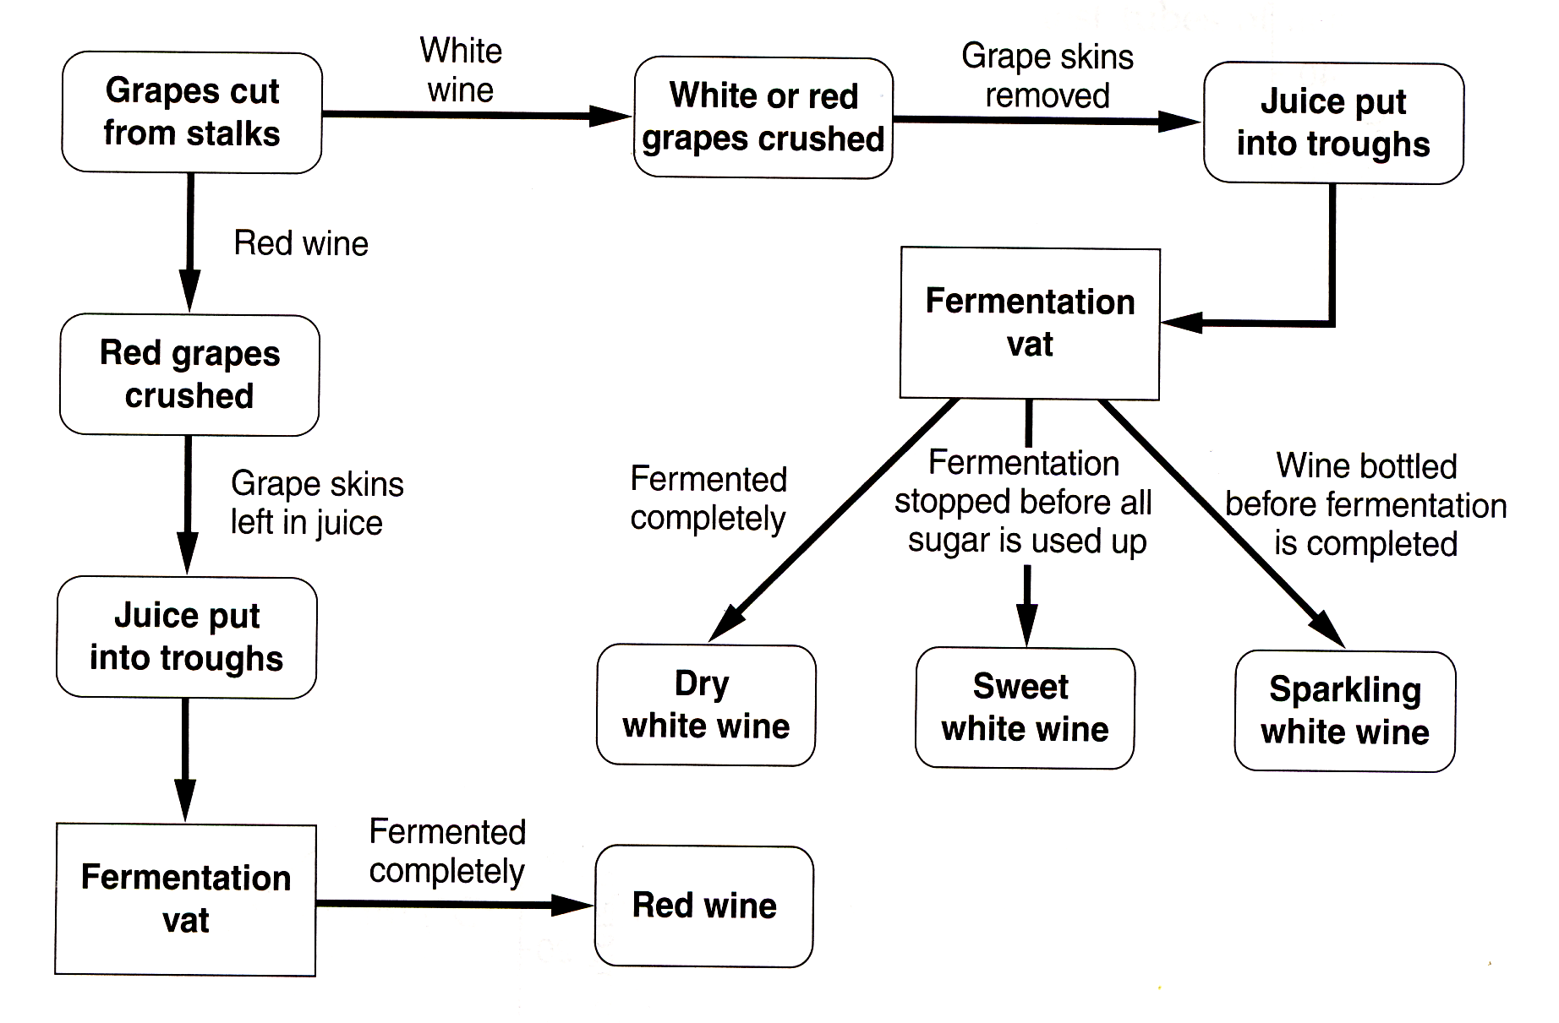

Question 23

Which wines are fermented completely before bottling?

(A) Red wine and dry white wine
(B) Red wine and sweet white wine
(C) Dry white wine and sweet white wine
(D) Dry white wine and sparkling white wine

Question 24

What is an advantage of presenting information in a flowchart?

(A) It shows trends in data.
(B) It shows how much of each product is made.
(C) It shows the sequence of steps in the process.
(D) It shows the length of time involved in each step.

Question 25

Why is fermentation an example of biotechnology?

(A) The products can be consumed.
(B) Grape vines are a renewable resource.
(C) Living things are used in this process.
(D) Living things are not harmed in this process.

Question 31
The circular key is used to identify some ores.

A particular ore is described as partly metallic and partly earthy. It is easily scratched by a knife blade and it has a brown streak.
What is the name of the ore?

(A) Haematite
(B) Limonite
(C) Magnetite
(D) Sphalerite

Refer to the chart to answer Questions 32–33.
The chart shows the range of frequencies that some musical instruments can produce.
Question 32

Which instrument has the smallest frequency range?

(A) Double bass
(B) French horn
(C) Timpani
(D) Tuba

Question 33

Which frequency can be produced on four of the five instruments?

(A) 100 Hz
(B) 325 Hz
(C) 400 Hz
(D) 750 Hz

Question 35

This key can be used to identify particles.

Using the key, what sort of particle is shown?

(A) Anion
(B) Atom
(C) Cation
(D) Molecule

Question 56

Within Earth, magma is heated causing it to rise. It then cools and sinks. What is the name given for this type of movement of magma?

Question 65 (5 marks)

A teacher used this dessert to model the geological history of sediments at a particular place.

(a) How could this dessert be used as a model to explain how geological history is interpreted? (2 marks)

(b) What geological reason could the teacher use to explain the absence of lollies in the bottom layer of jelly? (1 mark)

(c) Outline ONE advantage and ONE limitation of using this model to illustrate geological history.
(2 marks)

