School Certificate 2008
Revision Questions
Geology and Processing Information

- This set of questions comes from the School Certificate Science Test 2008. The highlighted section indicates which questions are included.

- Please use the separate Answer Booklet when recording your answers.

- This set of questions should be returned to your class teacher without any additions or alterations.

Section A Physics

Multiple Choice 16, 17, 23, 26, 27, 28, 39
Short Answer
Longer Answer 61

Section B Biology

Multiple Choice 2, 25, 31, 32, 33, 34, 37, 40
Short Answer 51, 52
Longer Answer 68

Section C Chemistry

Multiple Choice 1, 4, 5, 7, 20, 21, 22, 29, 30, 35, 36, 38, 41
Section D Geology and Miscellaneous

Multiple Choice 3, 6, 8, 9, 10, 11, 12, 13, 14, 15, 18, 19, 24,
Short Answer 57, 58, 59, 60
Longer Answer 63, 66

Section E Stimulus Booklet

Multiple Choice 42, 43, 44, 45, 46, 47, 48, 49, 50
Short Answer 53, 54, 55, 56
Longer Answer 62, 64, 65, 67

School Certificate Examination 2008

Set D : Geology and Processing Information Questions

Question 3

Which of the following measuring cylinders contains the largest volume of water? The cylinders are not drawn to scale.

A. 1
B. 2
C. 3
D. 4

Question 6

The cross-sections show widely separated outcrops of rock layers at locations X and Y.

Which rock layer is the oldest?

A. Green shale
B. Grey siltstone
C. Tan limestone
D. Unconsolidated glacial deposits

Use the sector graph to answer Questions 8–9.

Question 8

What percentage of the water used in Sydney homes in 2003 was used to flush toilets?

A. 10
B. 16
C. 20
D. 27

Question 9

Which of the following combinations uses the most water?

A. Bathroom and toilet
B. Bathroom and kitchen
C. Laundry and toilet
D. Outdoor and kitchen

Question 10

What causes sea-floor spreading and continental drift?

A. Varying sea levels
B. Convection currents in the mantle
C. Changes in Earth’s magnetic field
D. Contraction of the crust as Earth cools

Question 11

The shaded areas show the location of recent earthquakes in our region.

What is the best explanation of the location of these earthquakes?

A. Earthquakes occur in shallow oceans.
B. Earthquakes occur in an east/west line.
C. Earthquakes occur close to plate boundaries.
D. Earthquakes only occur close to coastal areas.

Question 12

The table provides information from a box containing breakfast cereal.

How much protein would be contained in a 50 g serving of this breakfast cereal?

A. 3 g
B. 4 g
C. 8 g
D. 83 g

Question 13

The Southern Cross is a constellation of stars in the night sky in the Southern hemisphere. It appears to rotate around a point in the sky in a clockwise direction and completes a whole revolution every 24 hours.

If the constellation appears as shown in the diagram above at 6 pm, what will it look like at 9 pm on the same night?

Refer to the graph and information to answer Questions 14–15.

Question 14

If Australia’s present population is 20 million people, how many cases of melanoma will occur this year?

A. 30
B. 600
C. 6000
D. 30 000

Question 15

What type of disease is melanoma?

A. Immune
B. Infectious
C. Non-infectious
D. Reproductive

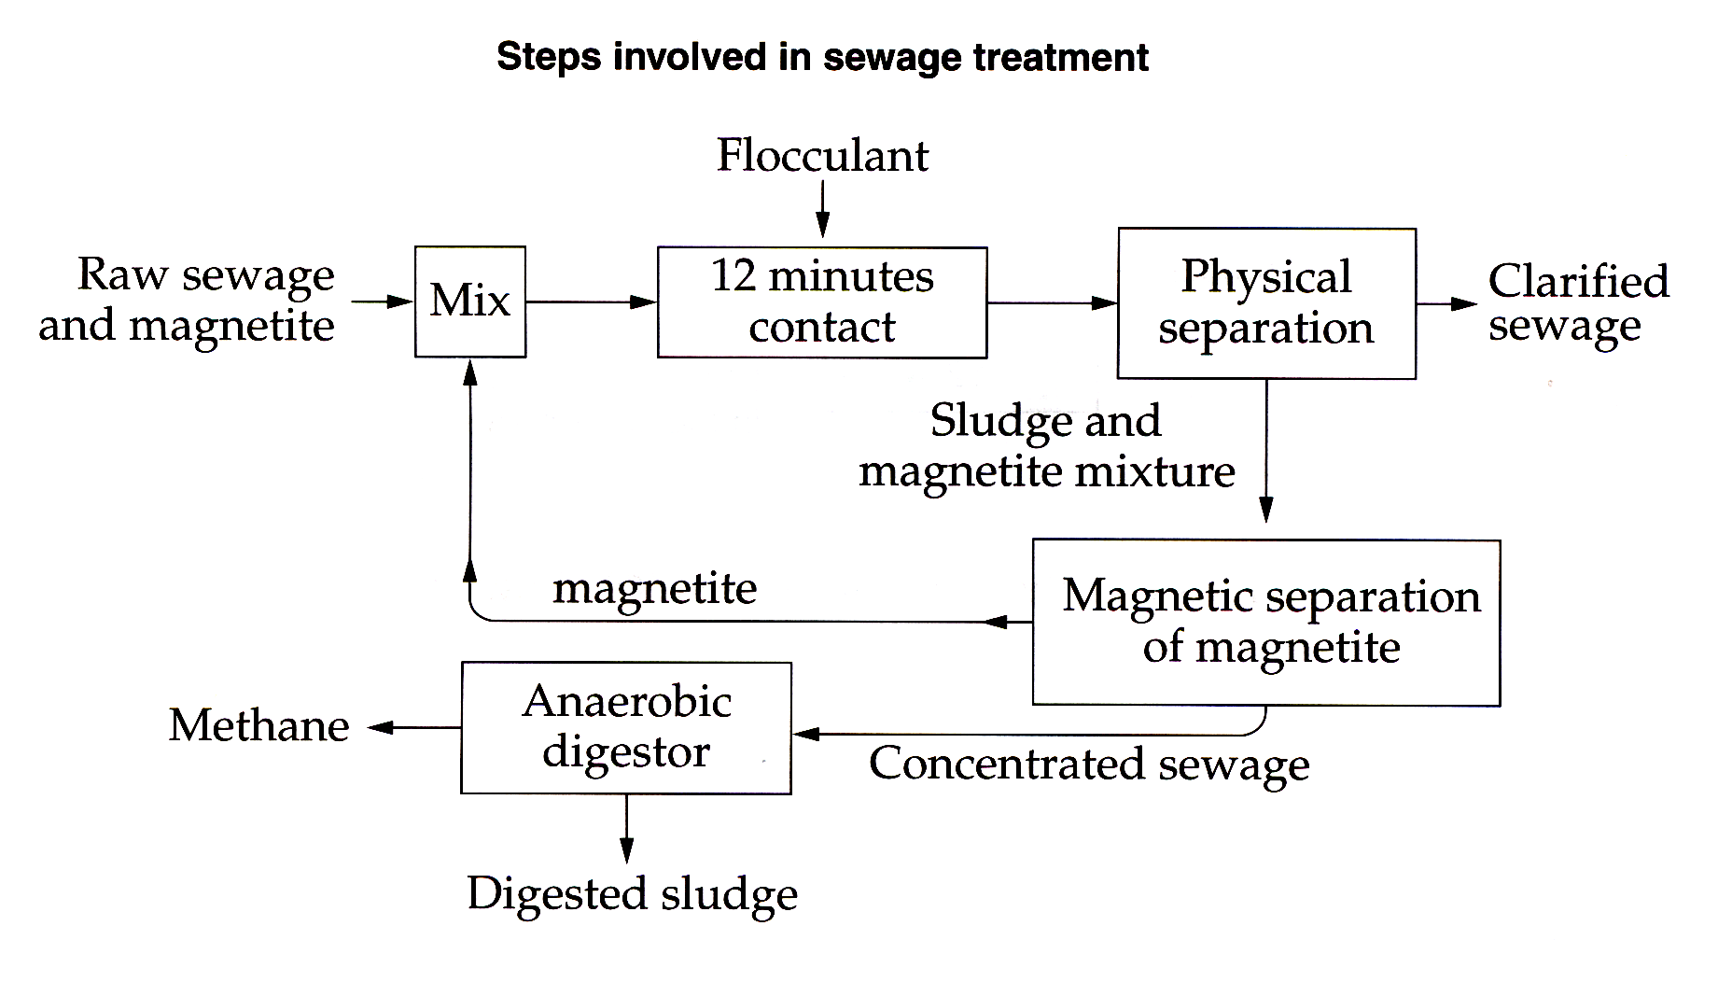
Refer to the flowchart to answer Questions 18–19.

Question 18

Which material is recycled in sewage treatment?

A. Clarified sewage
B. Digested sludge
C. Flocculant
D. Magnetite

Question 19

Methane produced in sewage treatment can be used as an alternative energy source.

What is an advantage of using sewage instead of fossil fuels as a source of methane?

A. Digested sludge is used in potting mix.
B. Methane from sewage is non-renewable.
C. Fossil fuel sources of methane will run out.
D. The methane from sewage will not pollute.

Question 24

Students studied the growth of 100 corn seeds and graphed the results.

Which alternative correctly identifies the independent and dependent variables in their investigation?

Use this graph to answer Questions 57–58.

A biologist was studying the number of live pups born to female dingoes in a particular area. The results were graphed. A litter is the term used for a group of babies born at the same time.

Question 57

How many litters were counted?

Question 58

What is the total number of live pups counted?

Use the table to answer Questions 59–60.

Four groups of students (A, B, C and D) carried out identical experiments to test
reaction time. The results of their experiments are shown.

Question 59

Which group has the least reliable set of results?

Question 60

Calculate the average reaction time for Group A.
Question 63 (2 marks)

Australian scientists have made contributions to society. Describe the effect of one of these contributions on people’s lives.

Question 66 (8 marks)

During your course you carried out first-hand investigations (experiments) to answer scientific questions. You have been asked to present a report on one of these investigations to your class.

(a) State the problem, hypothesis or question that you tested. (1 mark)

(b) Identify what you measured or observed. (1 mark)

(c) Briefly describe the features of your investigation that are examples of good experimental design.
(6 marks)

In your answer, include:

• how you carried out your investigation to obtain reliable results
• safety considerations
• how you recorded and analysed your results
• your conclusion

