‘’Growing Up Online’ DVD Analysis

Communication breakdown or Breakthrough?

Group work

1. How did the documentary present information pertaining to the ‘digital generation’? Was it a fair representation?
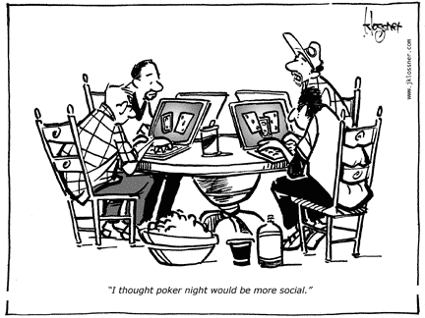

2. Are young people substituting on line communication for real life social interaction ?

3. Are the ‘connected generation’ socially disconnected? Use evidence from the DVD to support your answer

?

