‘’Growing Up Online’ DVD Analysis

Group work

1. How did the documentary present information pertaining to the ‘digital generation’? Was it a fair representation?

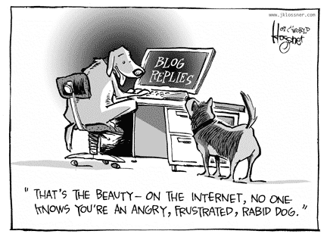
2. Are social networking sites just another way for adolescents to express their identity?

3.Do you think the anonymity that the Internet provides normalises otherwise unacceptable behaviour? Cyber bullying, anorexia groups etc Why?

