Year 10 Investigative Research Task

j0299125

Investigation Outline Booklet

10M1 to 10M2

2014

Trigonometry Tussles

# Answer All Questions on Your Own Paper

# Task 1

1. **Create a clinometer and hand it in with your assignment**

A clinometer is a tool that is used to measure the angle of elevation, or angle from the ground, in a right - angled triangle. You can use a clinometer to measure the height of objects that you can't practically measure. Follow the directions below to create your own clinometer.

You will need:

* A protractor with a small hole on the centre spot, or an old SNAP sheet or print out of a protractor glued onto thick cardboard
* 20 cm of string or strong cotton
* A weight - such as a metal nut, paper clips or a small piece of clay
* Glue and scissors
* A plastic drinking straw
* Clear adhesive tape

Straw

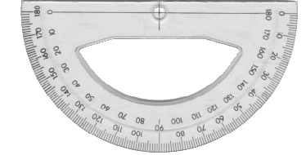

Look through this end for measuring angles of elevation.

String

Weight

***Figure 1:*** *The diagram shows what the assembled clinometer will look like when horizontal. The angle of elevation will be 0º.*

## Directions:

* With a thumbtack, nail or other sharp implement, poke a hole through the centre crossbar of the protractor.
* Push the string through the hole and tie a large knot on the other side so it won't pull through
* Tie the weight to the other end of the string
* Tape the straw so that it lies over the 90° marking on the protractor. Place it on the same side of the protractor as the knot, to allow the weighted string to swing freely.

## **Use the clinometer to measure the angle of elevation for a tree, building and two other objects.**

You will need two people to use the clinometer. One person to look through the straw and site the top of an object and one person to read the angle (in degrees) that the string makes with the protractor.

* Find a tall tree, a tall building and 2 other objects taller than yourself that you can reach the top of without standing on anything.
* Look through the straw and find the top of the tree.
* Ask your friend to read the angle being recorded on the clinometer. This is read where the string or cotton is touching the protractor.
* Measure the distance between where you are standing and the base of the tree.
* Measure the distance from your eyes to the ground (this is where your partner is indispensible!)

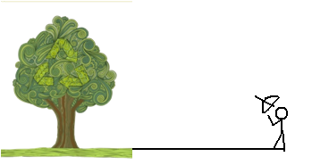

Clinometer

***Figure 2:*** *How to measure the angle of elevation using a clinometer*

Height from Your eye to the Ground

Angle of Elevation

## **Calculating the height of each object**

## Draw a diagram for each of the four objects, including the angle of elevation, your distance from the object, and your eye height.

1. Calculate the height of each object (tree, tall building, and two other objects), showing all working. Working should include the following:

* Correct trigonometric ratio (1 mark each object)
* Correct side length of triangle (1 mark each object)
* Addition of eye height for total height of object (1 mark each object)
* Correct units and answer to 1 decimal place (1 mark each solution object)

1. **Create a visual presentation**

Using a comic strip creation website to create a comic strip, or an alternative computer-based pictorial method, to explain the process you went through to **measure** **the height of the tree.** Websites to try include

* <http://stripgenerator.com/strip/create>
* <http://www.toondoo.com/>
* [www.comeeko.com](http://www.comeeko.com)
* [www.pikistrips.com](http://www.pikistrips.com)
* <http://www.makebeliefscomix.com/Comix/>

Alternative computer-based methods include *PowerPoint*, Photostory or a poster (using printed photos). No hand-drawn comics! The comic strip must have a minimum of 5 panels.

# Task 2A

1. **(2 marks) Select 3 points on *Google Earth* which form a NON right-angled triangle**

Using *Google Earth*, locate a town (or place) of your choice. Zoom in and find a suitable location for the **start** of a carrier pigeon race. **Choose 2 suitable stopping points** for the pigeons along the way.



Ensure that your 3 points **DO NOT** form a right-angled triangle!

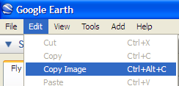Copy your image into *Paint* or another image editing program e.g. *SMART Notebook*, *Photoshop Elements, Fireworks* etc.

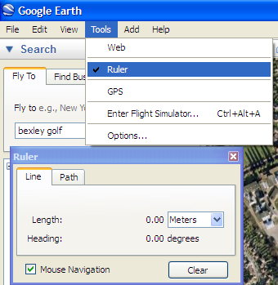Draw the 3 points onto your image, using the image editing program, and the lines to complete the triangle.  
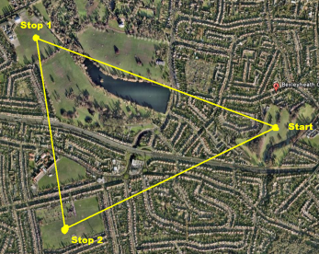

**b) (2 marks) Use the measuring tools in *Google Earth* to measure distances**

Using the measuring tool in *Google Earth*, take measurements and complete the following information below. Make sure you include all units used.

To use the **Ruler tool** in *Google Earth*, click once on the start of the distance and once on the end of the distance.

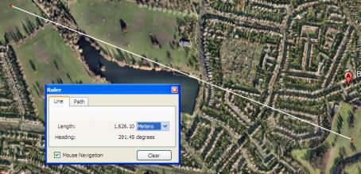Measure the **distances**:

Stop 1 to Start = _________________

Stop 1 to Stop 2= ________________

1. **(4 marks) Use the protractor in *Google Earth* to correctly calculate bearings**

* Using a protractor on the screen, measure the **bearings** from:

Stop 1 to Start = ______________

Stop 1 to Stop 2 = _________________

* Using a protractor on the screen, measure the **angle**

<Start/Stop1/Stop2 = _____________________

Start

**Example**

Stop 1

Stop 2

# Task 2B

Use the formulae below and your answers from Tasks 2A to complete the following questions

**Sine Rule Area of a Triangle**

$\frac{a}{\sin{a}}=\frac{b}{\sin{b}}=\frac{c}{\sin{c}}$ $A=\frac{1}{2}absin c$

**Cosine Rule**

$c^{2}=a^{2}+b^{2}-2ab\cos{C}$ or $\cos{C=\frac{a^{2}+b^{2}-c^{2}}{2ab}}$

------------------------------------------------------------------------------------------------------------------------------------

1. (3 Marks) Use the measurements you took in Task 2A, and an appropriate trigonometric rule, to calculate the direct distance between the **start** and **stop 2** points of the race. State the rule used and show all working, including a diagram.
2. (3 Marks) Use the **Sine Rule** to calculate the angles. Show all working, including a diagram.

<Stop 1/Start/Stop2 and <Stop 1/Stop 2/Start

1. (2 Marks) Calculate the **area of the triangle** that the pigeons would fly around.

**Task 3 is on the next page.**

**TASK 3**

Some of the early ways of measuring the height of tall structures are still in use today. They require very little equipment and can be used out in forests where special equipment is hard to come by. We are going to look at three methods. You will then compare your results to discover if the answers you get are close - they should be. After all, the tree doesn't change its height because you change your measurement method! You might be surprised just how accurate you can be

1. Native Americans had a very interesting and unusual way of seeing how high a tree was. They would bend over and look through their legs!

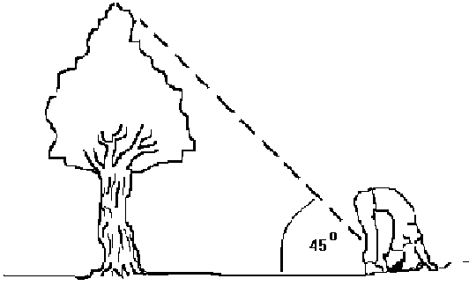

***Figure 3:*** *How to find the height of a tree Native American Indian style.*

They would walk far enough from the tree to a find a place where they were just able to see the top of the tree (from their upside down position). The distance from this place to the base of the tree was approximately the height of the tree.

Does it work? Actually it does and the reason is rather simple. For a normal, fit and healthy adult (one who can bend over in such a way), the angle that is formed as they look through their legs is approximately 45 degrees. The angle between the tree trunk and the ground is fairly close to 90 degrees and, using what you know about the angles and sides of a triangle you can work out the height of the tree. The height of the tree and the distance from the tree to the person is about equal. Therefore, knowing the distance to the tree gives you a good idea about the height of the tree. It certainly saves having to carry heavy surveying equipment around.

**Questions:**

(a) Draw a diagram similar to Figure 3, showing how you used this method, labelling all measurements (all three angles, your distance from the tree, the height of the tree).

(b) What sort of triangle did you draw?

(c) Why does this method work in finding the height of the tree? (Hint: what are the properties of the triangle?)

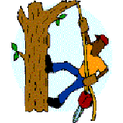

1. Loggers are people who cut down trees. They learned a great deal from people who lived in forests for generations, like the Native Americans. They might be cutting down trees that are over a certain height and it is important that they have an easy way to estimate which of the trees around them are to be cut. You can try and estimate the height of a tree or a building using their method.

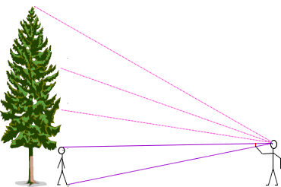

***Figure 4:*** *How to find the height of a tree Tree Logger method.*

You need a partner who stands at the base of the tree. Move a distance away from the tree then, holding your pencil at arms' length, between your thumb and forefinger so that it brackets the height of your partner (the top and bottom of the pencil coincide with the top of the head and the bottom of the feet of your partner). Now, use this length to step out the height of the tree in "pencil lengths". You can now measure the height of your partner and multiply this by the number of pencils high the tree is. This is worth doing several times from different distances and working out an average to improve the accuracy.  
  
This is quite easy, once you have the knack. Describing the method makes it sound way more complicated than it is. After a couple of tries, you'll be able to apply for a lumberjack's job!

**Questions:**

1. What was the height of your partner (to the nearest centimetre)?
2. How many “pencil lengths” did you estimate to fit into the height of the tree?
3. Show your calculation for how you worked out the height of the tree. Give your answer in metres to 1 decimal place.
4. Now try a third method. Don't forget to be comparing the sizes that you are getting for the tree height to see how they match up.  
   You will need a partner again, and another thing that you will need is a sunny day. You might have to pick your time for this experiment.  
     
   We'll call this method Measuring Shadows. Wait until the tree casts a shadow then measure the length of the shadow. Stand next to the tree and have a friend or parent measure your shadow. Be sure to do it as soon as you can after you measure the tree shadow, since shadows cast by the sun continually change as the earth rotates. Measure your height to find out how tall you are. Now for the good part - get those calculators out! You will need the 3 measurements:

* the length of the tree's shadow
* the length of your shadow
* your height

Divide the length of the tree's shadow by the length of your shadow. Then multiply the answer by your height. This will tell you how tall the tree is!

**(Tree's Shadow / Your Shadow) x Your Height = Tree's Height**

**Questions:**

1. What was the length of the tree’s shadow?
2. What was the length of your shadow?
3. What was your measured height?
4. Calculate the tree’s height, showing your working. Give your answer in metres to 2 decimal places.
5. Which of the four methods (Clinometer, Native American Indian, Lumberjack or Measuring Shadows) in this task would you prefer to use, and why?

**End of Task**.

Make sure that you have your name on all pages that are to be handed in and that they are stapled and put into a plastic sleeve. Then hand it to your teacher.

**MARKING GUIDE TRIGONOMETRY TASK 5.3**

NAME__________________________________ Class ______

|  |  |  |
| --- | --- | --- |
| **Criteria for tasks 1** | **Allocated marks** | **Student** |
| 1. Create a clinometer that works, and hand it in with your assignment | 2 |  |
| 1. Measure the angle of elevation of a tree, tall building, and two other objects using your clinometer | 4 |  |
| (i) Represent each object with a diagram, including the angle ofelevation, your distance from the object, and your eye height (total of4 diagrams)  1. Calculate the height of each object (tree, tall building, and two other objects), showing all working. Working should include the following:  * Correct trigonometric ratio (1 mark each object) * Correct side length of triangle (1 mark each object) * Addition of eye height for total height of object (1 mark each object) * Correct units and answer to 1 decimal place (1 mark each solution object) | 4  16 |  |
| Create a visual presentation, minimum length of 5 panels, to explain the process involved in calculating the height of a tall object. Marks will be awarded for including:Use of comic-strip creation website or alternative computer-based method5 or more panelsAn appropriate use of mathematical language / notationCorrect spellingLogical sequencing of explanationVisual effectiveness | 6 |  |
| **Task 1 Total** | **/32** | **/32** |

|  |  |  |
| --- | --- | --- |
| **Criteria for task 2A** | **Marking scale** | **Student** |
| 1. Triangle which is not right-angled   Any other triangle or only two points  No triangle | **2**  **1**  **0** |  |
| 1. 3 lines drawn and distance measured   Only partially correct  Nothing correct | **2**  **1**  **0** |  |
| 1. Angles measured (1 mark for each angle) | **3** |  |
| **Criteria for Task 2b** |  |  |
| 1.  Rule stated and calculation done correctly  No rule but calculation done correctly or rule and answer only (no working)  Correct rule and no working or correct answer only.  Nothing correct | 3  2  1  0 |  |
| 2  All correct  Only two parts correct i.e. diagram and answer only/correct working and no diagram  Only correct piece of answer  Nothing correct | 3  2  1  0 |  |
| 3.  Area formula stated and correct answer  Answer only correct, or correct substitution and wrong working  Nothing correct | 2  1  0 |  |
| Task 2 total | /15 | /15 |
| **Criteria for task 3** | **Marking scale** | **Student** |
| 1)   1. Correctly draw a diagram (all angles, distance from tree, height of tree) 2. Recognise the type of triangle drawn 3. Give a description on why this Native American Indian method of measuring tree height works, using the properties of the triangle | 3 |  |
| 2)   1. Give partner’s height to the nearest centimetre 2. How many “pencil lengths” did you estimate to fit into the height of the tree? 3. Calculate the height of the tree, showing your working. Give your answer in metres to 1 decimal place.   3)   1. What was the length of the tree’s shadow? 2. What was the length of your shadow? 3. What was your measured height? 4. Calculate the tree’s height, showing your working. Give your answer in metres to 2 decimal places.   4) Which of the four methods (Clinometer, Native American Indian, Lumberjack or Measuring Shadows) in this task would you prefer to use, and why? | 3  4  2 |  |
| **Task 3 total** | **/12** | **/12** |
| **Total** | **/44** | **/59** |

TEACHER COMMENTS