Yr 10 Term One Ecosystems
Homework Assignment 1 Due: …… / …… / 20……
This sheet is to be placed in your homework folder and handed in for marking on the due date. Keep all completed homework sheets in your homework folder as they will make an excellent study resource. Credit will be given for completed homework sheets.

Knowledge
You should be able to find answers to these questions by reviewing your Science notebook. These are the style of questions that you can expect in the Knowledge section of your term test.

1. Briefly define an ecosystem.
…………………………………………………………………………
…………………………………………………………………………
…………………………………………………………………………

2. Define the term abiotic.
………………………………………………………………………………………………………………………………………………………………………………………………………………………………

3. Identify five abiotic factors that occur in a named ecosystem.
………………………………………………………………………………………………………………………………………………………………………………………………………………………………

4. Identify five biotic factors that occur in a named ecosystem.
………………………………………………………………………………………………………………………………………………………………………………………………………………………………

5. Using the internet, research an Australian ecologist. Give some details about this scientist’s life e.g. the area that they grew up in, birth date, etc.
…………………………………………………………………………
…………………………………………………………………………
…………………………………………………………………………
…………………………………………………………………………

6. Use your knowledge from class and use of the internet to match the scientific instrument with the abiotic factor being measured.
Hint: use the word list below

Cobalt chloride paper pointed metal rod dry/wet thermometer thermometer light meter pH paper

Scientific instrument | Abiotic factor
 | Temperature
 | Humidity
 | Wind speed
 | Amount of light
 | Soil depth
 | Soil moisture
 | Soil pH

Practical Investigations
These questions are about planning and conducting practical investigations. You will need to think about the practical work that you have completed in class. The answers to these questions may not be in your Science notebook.

7. Some of the following statements are observations and some are inferences. Write an O next to the statement if you believe it is an observation. Write an I next to the statement if you believe it is an inference. Write O and I if it both.
The temperature recorded on a thermometer ……
The number of possums in the school and surrounding area. ……
The population of ants in C block ……
The rain fall across Newcastle next month ……
The wind speed as measured with a anemometer in the quad. ……

8. You have been asked to survey the school grounds for the number of Native Minor Birds that visit over a two week period. Determine the equipment required and write a proposed method for the activity.
……………………………………………………………………
……………………………………………………………………
……………………………………………………………………
……………………………………………………………………
……………………………………………………………………
……………………………………………………………………
……………………………………………………………………
……………………………………………………………………

Processing Data and Information
These questions are about looking at information and trying to work out something new from it. All the information that you need is in the question. It is not likely that you will find the answers to these questions in your Science notebook.

9. Look at the following information:
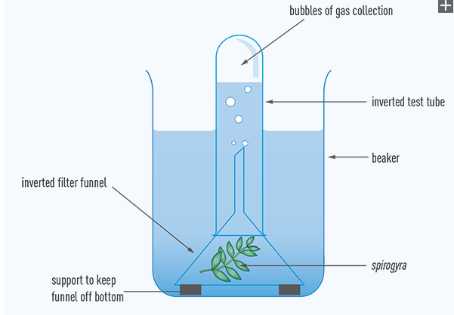
Aquatic plant
(a) Name the gas that you would expect to be collected by the inverted test tube.
……………………………………………………………………
(b) What inferences can be made from the above answer about the process that the plant is undertaking in the water?

……………………………………………………………………
……………………………………………………………………
……………………………………………………………………
……………………………………………………………………

Communicating Scientific Information
These questions are about putting information into appropriate formats. You may find some of the answers in your Science notebook. It is more likely that you will have to rearrange the information that you are given into a more suitable format.

Drawing lines of best fit
Graphs are very useful when you are looking for a pattern in your results. However, sometimes you have to draw a line of best fit so that you can see this pattern clearly. For example, in an experiment on fitness, Matthew recorded Sarah’s pulse rate and breathing rate. He then plotted the graph
below.
Notice that the points lie roughly on the straight line. This is called a straight line of best fit.

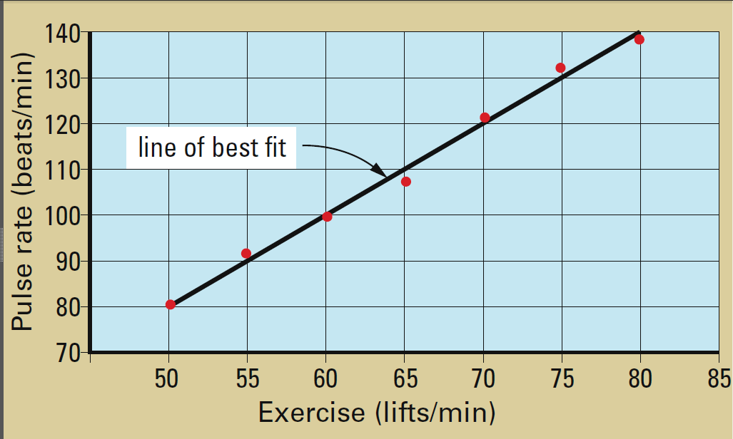

Drawing lines of best fit takes practice! The line doesn’t need to go through all the points. It has to pass close to as many points as possible.

Draw a straight line of best fit for the following data on the graph at the bottom of the page.
Hint: remember the axis labels, units and title.

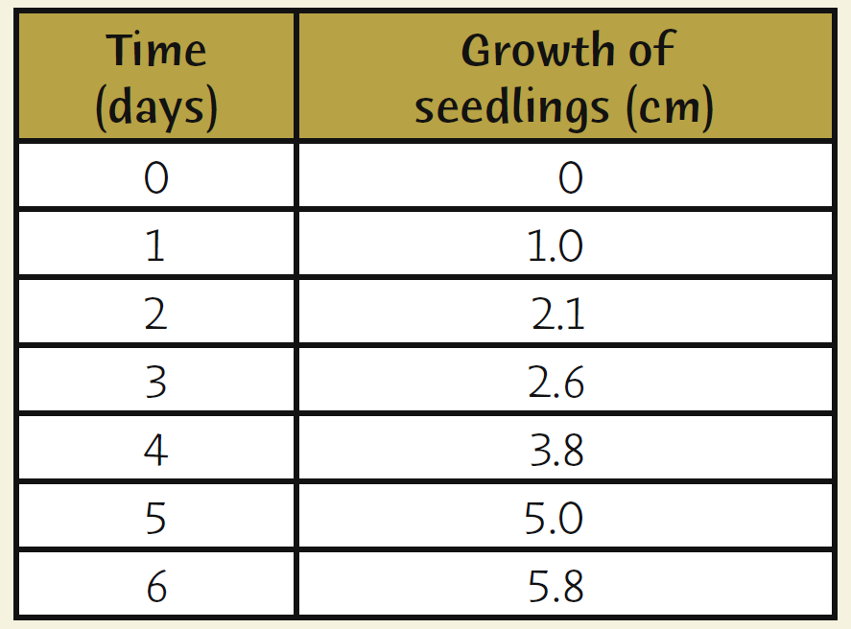

Parent’s signature ………………………………… Date: …… / …… / 20 ……
Teacher’s signature ………………………………… Date: …… / …… / 20 ……

