Yr 10 Term One Ecosystems
Homework Assignment 2 Due: …… / …… / 20……
This sheet is to be placed in your homework folder and handed in for marking on the due date. Keep all completed homework sheets in your homework folder as they will make an excellent study resource. Credit will be given for completed homework sheets.

Knowledge
You should be able to find answers to these questions by reviewing your Science notebook. These are the style of questions that you can expect in the Knowledge section of your term test.

1. The c........................ and the r............................... between individuals in a community make up the biotic part of the e......................

2. In every community you will find p......................, herbivores, c........................... and d...........................

3. Sort the following types of relationships in ecosystems into the table below.
predator- prey mutualism parasitism
commensalism symbiosis
Beneficial | Neutral | Harmful
4. Identify one similarity and one difference between a predator- prey relationship and parasitism.
…………………………………………………………………………
…………………………………………………………………………
…………………………………………………………………………
5. Using the internet, research an Australian example of a symbiosis relationship. Give some details about these organisms, how they are affected by the relationship and what effect it may have on the organism’s survival if they didn’t co-exist.
…………………………………………………………………………
…………………………………………………………………………
…………………………………………………………………………
…………………………………………………………………………

6. Copy and complete the following table about interspecific relationships by describing how the two species in this type of relationship are harmed, benefitted or unaffected:
Mutualism | Symbiosis | Commensalism | Predator- prey | Parasitism

7. Outline why it important to have a variety of producers, consumers and decomposers in an ecosystem.

…………………………………………………………………………
…………………………………………………………………………
…………………………………………………………………………

8. Explain why ecological balance is important. Give at least one reason.
…………………………………………………………………………
…………………………………………………………………………
Practical Investigations
These questions are about planning and conducting practical investigations. You will need to think about the practical work that you have completed in class. The answers to these questions may not be in your Science notebook.

9. During your study of this topic, you conducted an experiment to determine competition within a population of seedlings.
List the variables you could measure to determine if competition did occur.
……………………………………………………………………
……………………………………………………………………
……………………………………………………………………

10. Are there any other factors that might affect the growth of the seeds.
……………………………………………………………………
……………………………………………………………………
……………………………………………………………………

11. There are many examples of competition between organisms in the real world. Identify one example that you are aware of (you might need to do some research).
……………………………………………………………………
Describe how you could test for competition in the above example.
……………………………………………………………………
……………………………………………………………………
……………………………………………………………………
……………………………………………………………………
……………………………………………………………………
……………………………………………………………………
Processing Data and Information
These questions are about looking at information and trying to work out something new from it. All the information that you need is in the question. It is not likely that you will find the answers to these questions in your Science notebook.

Look at the following information:
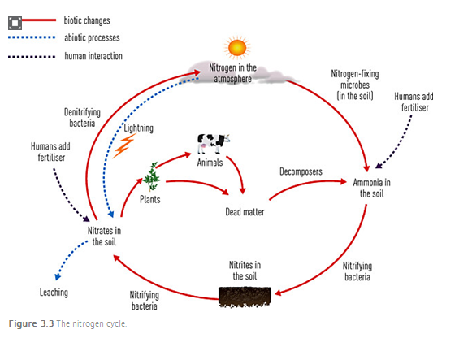
12. Identify one way nitrogen gas can be converted to nitrates and added to the soil by abiotic processes.
……………………………………………………………………
13. Identify one way ammonia can be added to the soil by biotic processes. ………………………………………………….
……………………………………………………………………
……………………………………………………………………
14. Identify the type of organism which converts nitrites into nitrates.
……………………………………………………………………
Communicating Scientific Information
These questions are about putting information into appropriate formats. You may find some of the answers in your Science notebook. It is more likely that you will have to rearrange the information that you are given into a more suitable format.

The ecological footprint of a population is the area of land and water
required to supply the resources the population needs and to cope with
the wastes produced by it.
Table 1 The ecological footprint of some of the largest economies
Country | Hectares per person
India | 0.9
China | 1.7
Malaysia | 2.2
Ireland | 3.8
Netherland | 4.2
Japan | 4.3
Germany | 4.2
UK | 5.6
NZ | 6
Australia | 6.3
Canada | 7.6
USA | 9.1

1. Graph the data in the table above to display the ecological footprint of the major economies in the world on the grid provided. The graph should be a COLUMN GRAPH, have a heading/title, and each axis must have an even scale and be labelled (named) including units.

- Compare the ecological footprint of Australia with the ecological footprint of USA, India and Germany.
……………………………………………………………………
……………………………………………………………………
……………………………………………………………………
……………………………………………………………………
……………………………………………………………………
- Describe four ways in which protecting ecosystems can also give people an income.
……………………………………………………………………
……………………………………………………………………
……………………………………………………………………

Parent’s signature ………………………………… Date: …… / …… / 20 ……
Teacher’s signature ………………………………… Date: …… / …… / 20 ……

