Yr 10 Term One Ecosystems
Homework Assignment 3 Due: …… / …… / 20……
This sheet is to be placed in your homework folder and handed in for marking on the due date. Keep all completed homework sheets in your homework folder as they will make an excellent study resource. Credit will be given for completed homework sheets.

Knowledge
You should be able to find answers to these questions by reviewing your Science notebook. These are the style of questions that you can expect in the Knowledge section of your term test.

- State whether the following are true(T) or false(F):
- Food chains start with producers.
- An herbivore is a first-order consumer.
- All consumers are carnivores.
- Decomposers and bacteria are not important in food webs.
- Food webs in nature are in delicate balance. They can easily be destroyed.
- Write a word equation and a symbol equation for photosynthesis.
................................................................................................................................................................................................................................................................................................................................................................................................................................................
- What is phytoplankton? Explain its importance to ocean ecosystems.
................................................................................................................................................................................................................................................................................................................................................................................................................................................

- Identify the organisms that are responsible for converting nitrogen from the air into a form that plants can take up.
............................................................................................................
- Define the terms distribution and abundance.
................................................................................................................................................................................................................................................................................................................................................................................................................................................
- Identify one important difference in the way that traditional Aborigines and Torres Strait Islander people obtained food.
....................................................................................................................................................................................................................................................................................................................................
- Imagine you are lost in the arid Australian outback. Identify the main abiotic factors that would make your survival difficult.
................................................................................................................................................................................................................................................................................................................................................................................................................................................
- Describe in your own words what a sustainable ecosystem is.
....................................................................................................................................................................................................................................................................................................................................
- What activities put pressure on sustainable ecosystems? Give an example.
............................................................................................................
............................................................................................................
Practical Investigations
These questions are about planning and conducting practical investigations. You will need to think about the practical work that you have completed in class. The answers to these questions may not be in your Science notebook.
- The location of five different types of trees in the two quadrats below is indicated by the five different symbols.
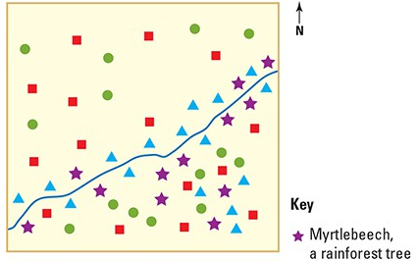
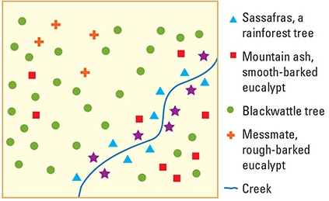

- Count and record the number of the different species in each quadrat. Record your count in a table in the space below.

- Identify which quadrat provides a greater variety of habitat types for wildlife. Explain your answer.
………………………………………………………………………………………………………………………………………………………………………………………………………………………………………………………………………………………………………………………………………………………………………………………………………………………………………………………………………………………………………………………………………………………………………………
- Propose why the rainforest species in both quadrats are located most densely near the creek.
………………………………………………………………………………………………………………………………………………………………………………………………………………………………………………………………………………………………………………………………………………………………………………………………………………

Processing Data and Information
These questions are about looking at information and trying to work out something new from it. All the information that you need is in the question. It is not likely that you will find the answers to these questions in your Science notebook.

11. a) Use the information below to construct a food web for a coastal ecosystem:
Organism | What it Feeds on
Seabird | Crab, mussel, small fish
Human | Crab, mussel, small fish, large fish
Shark | Large fish
Large Fish | Small Fish
Small Fish | Phytoplankton, algae (both Producers)
Worms | Phytoplankton, mussel
Construct your food web here.

b) Predict the impact of over-fishing of the large fish on the abundance of sharks, the small fish and crabs.
………………………………………………………………………………………………………………………………………………………………………………………………………………………………………………………………………………………………………………………………………………………………………………………………………………

Communicating Scientific Information
These questions are about putting information into appropriate formats. You may find some of the answers in your Science notebook. It is more likely that you will have to rearrange the information that you are given into a more suitable format.

A concept map can be used to link all the major words in a chapter together. The line joining the words together can be used to explain the link.
Draw a concept map using the following words:

Ecosystems, environments, habitats, predators, prey, producers, interactions, consumers, organisms.

An example of the type of concept map you can draw has been started for you here.

Environments

Ecosystems habitats

Interactions

Mutualism commensalism collaboration

Parent’s signature ………………………………… Date: …… / …… / 20 ……
Teacher’s signature ………………………………… Date: …… / …… / 20 ……

