**Term Two To zoo or not to zoo**

Homework Assignment 1 Due: …... /…... / 20……

Are zoos bad/good? This is the question you need to answer. Using your notes, any further study you have done and your opinion, write a persuasive argument to answer this question.

To help you do this, we have provided you with a scaffold. So before you write your argument for or against on the next page, fill in the scaffold below.

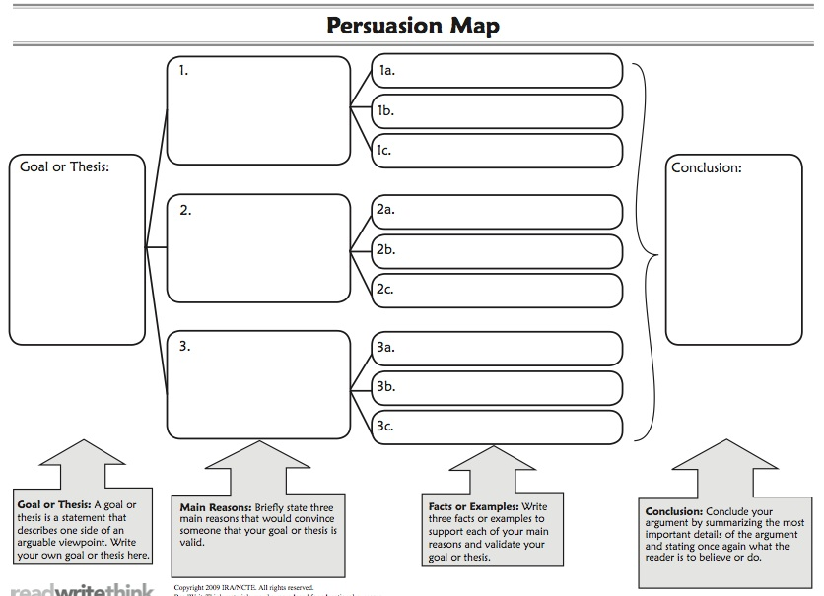

Now that you have done that, use the ideas above to persuade a friend or family member to understand your point of view.

____________________________________________________________________________________________________________________________________________________________________________________________________________________________________________________________________________________________________________________________________________________________________________________________________________________________________________________________________________________________________________________________________________________________________________________________________________________________________________________________________________________________________________________________________________________________________________________________________________________________________________________________________________________________________________________________________________________________________________________________________________________________________________________________________________________________________________________________________________________________________________________________________________________________________________________________________________________________________________________________________________________________________________________________________________________________________________________________________________________________________________________________________________________________________________________________________________________________________________________________________________________________________________________________________________________________________