**Term Two To zoo or not to zoo**

Homework Assignment 2 Due: …... /…... / 20……

This sheet is to be placed in your homework folder and handed in for marking on the due date. Keep all completed homework sheets in your homework folder as they will make an excellent study resource. Credit will be given for **completed** homework sheets.

**Knowledge**

*You should be able to find answers to these questions by reviewing your Science notebook. These are the style of questions that you can expect in the Knowledge section of your term test.*

1. Copy and complete the following sentences.
2. Food chains generally begin with …………… or ………………
3. Animals that eat other animals are called ……………….
4. In food chains and webs, plants and algae are called …………… because they make their own food.
5. The energy needed by plants and algae to make their own food comes from …………….
6. …………. and ……………, which break down the bodies of dead organisms, are called ………….
7. Some of the following statements are false. Select the false ones and rewrite them in the space below to make them correct.
8. Producers make their food by the process of photosynthesis.
9. First-order consumers are also called carnivores.
10. Organisms that contain chlorophyll are called consumers.
11. A domestic cat could be classed as a first order consumer.
12. Decomposers break down the bodies of dead organisms and recycle the materials in the food web.

……………………………………………………………………………………………………………………………………………………………………………………………………………………………………………………………………………………………………………………………………………………………………………………

………………………………………………………………………………………………………………………………………………………………………………………………………………………………………………………………………………………………

1. The diagram below shows a typical fish tank.

[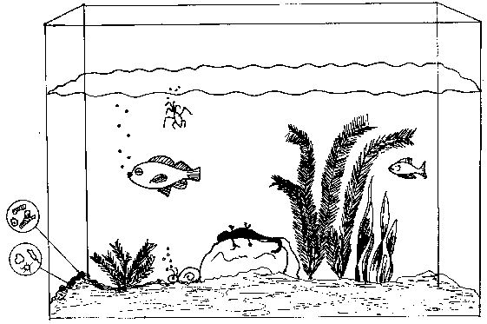](http://www.google.com.au/url?sa=i&rct=j&q=&esrc=s&frm=1&source=images&cd=&docid=eFLXP5eVxmD_mM&tbnid=XdwsYE3nmeiksM:&ved=0CAUQjRw&url=http://www.msnucleus.org/membership/html/k-6/lc/ntenvn/4/lcne4_6d.html&ei=H-g4UvzMN8PdkgWI7ICQDA&bvm=bv.52164340,d.dGI&psig=AFQjCNHHkYHht-OmriLlNGVqVPzgJW4asg&ust=1379547541266206)

List 2 abiotic and 2 biotic factors within this ecosystem in the table provided.

|  |  |
| --- | --- |
| **Abiotic Factors** | **Biotic Factors** |
|  |  |

**Practical Investigations**

*These questions are about planning and conducting practical investigations. You will need to think about the practical work that you have completed in class. The answers to these questions may not be in your Science notebook.*

Photosynthesis is the process by which plants make their own food.

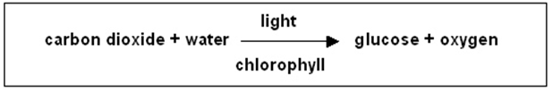

1. A science class performed the experiment below to test various aspects of photosynthesis.

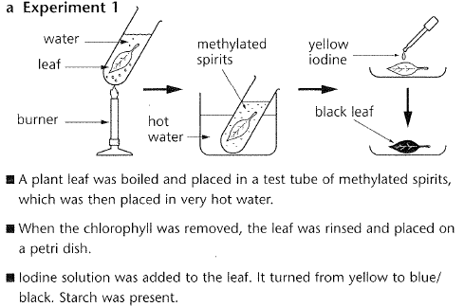

1. Explain how this experiment can be made more **reliable**?

…………………………………………………………………………………………………………………………………………………………

1. Suggest one way which the experiment could be more **accurate**?

……………………………………………………………………………….

1. Identify **one** safety risk **AND** the precaution taken to reduce this risk.

………………………………………………………………………………………………………………………………………………………………

**Processing Data and Information**

*These questions are about looking at information and trying to work out something new from it. All the information that you need is in the question. It is not likely that you will find the answers to these questions in your Science notebook.*

1. Use the food web to answer the following questions

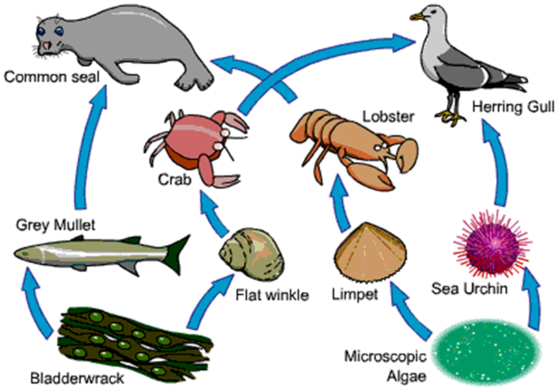

* 1. Name a producer, consumer and top predator.
     1. Producer …………….
     2. Consumer………………
     3. Top Predator………………..
  2. Predict what would happen to Limpet populations if the common seal became extinct.

………………………………………………………………………………………………………………………………………………………………………………………………………………………

* 1. What do the arrows mean in a food web? …………………………………………………………………..
  2. Explain what would happen to at least 3 other organisms if the Bladderwrack became extinct. ……………………………………………………………………………………………………………………………………………………………………………………………………………………………………………………………………………………………………………………………………………

**Communicating Scientific Information**

*These questions are about putting information into appropriate formats. You may find some of the answers in your Science notebook. It is more likely that you will have to rearrange the information that you are given into a more suitable format.*

The following information describes some food chains within an ecosystem.

Grass 🡪 Rabbit 🡪 Fox

Grass 🡪 Green Fly 🡪 Frog 🡪 Fox

Grass 🡪 Green Fly 🡪 Frog 🡪 Hawk

Grass 🡪 Green Fly 🡪 Vole 🡪 Fox

Grass 🡪 Green Fly 🡪 Vole 🡪 Hawk

Grass 🡪 Green Fly 🡪 Chaffinch 🡪 Hawk

Grass 🡪 Slug 🡪 Chaffinch 🡪 Hawk

Feeding relationships within an ecosystem are more effectively shown in a food web. Draw these food chains as a web in the space opposite.

Parent’s signature …………………… Date: …… / …… / 20 ……

Teacher’s signature …………………… Date: …… / …… / 20 ……